This QRG provides the steps to cancel one or more lines on a purchase order (PO) in D365 F&SCM. Canceling a PO line stops further processing or receiving for that line while keeping a record of the original entry.
Contents
Cancel Purchase Order Lines 1

Cancel Purchase Order Lines
- The PO must be in Confirmed or Open order status.
- A line that has already been fully received or invoiced cannot be canceled.
- Always verify with Procurement or Accounting before canceling lines tied to encumbrances or commitments.

To cancel a Purchase Order line:

- Navigate to Procurement and Sourcing > Purchase orders > All purchase orders.
- Locate and open the purchase order that requires line cancellation.
- Go to General > Related information > Line quantity to review quantities invoiced and quantities remaining. 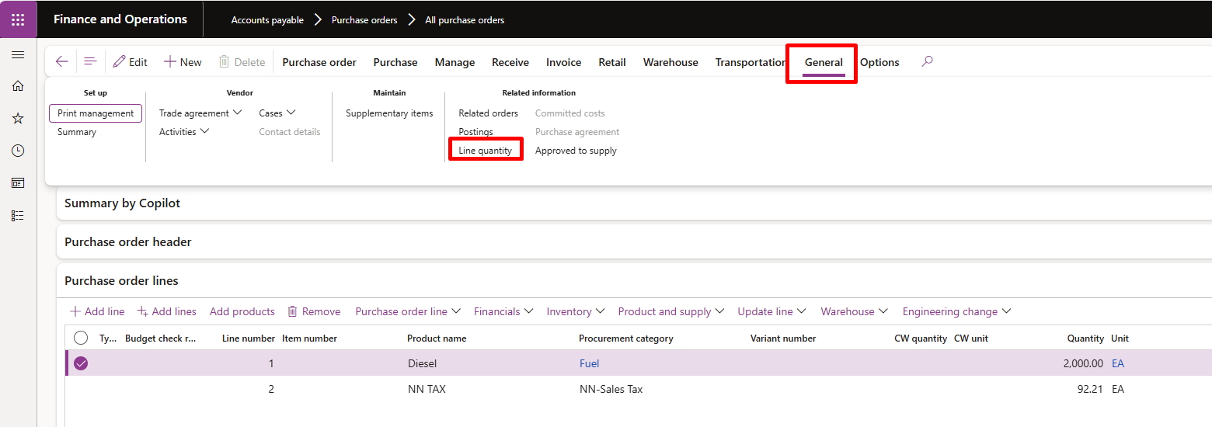
The Line quantity form displays all PO line quantities.
The Deliver remainder field shows the quantity available for cancellation.

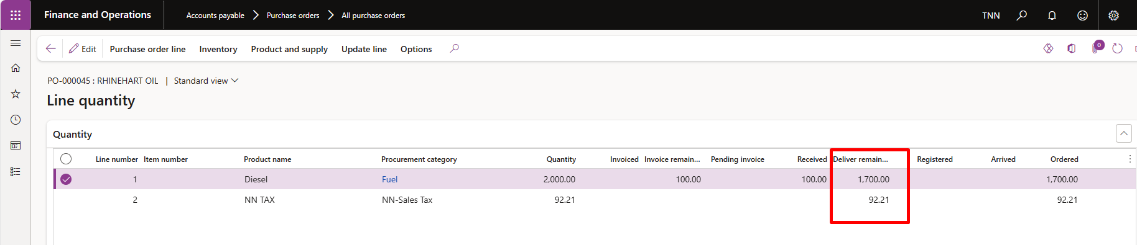

To cancel partial quantities:

- On the Action Pane, click Update line > Update > Deliver remainder.
- In the Update remaining quantity field, enter the quantity still expected to be received on this PO.
- Click OK.
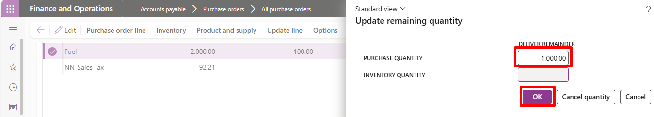

- The Deliver remainder value updates to reflect the new remaining quantity to be received. 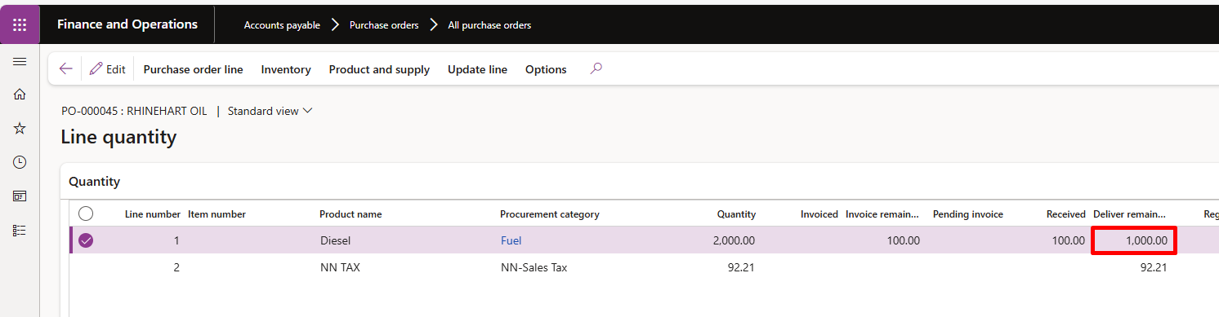

To cancel quantities on the PO:

- On the Action Pane, click Update line > Update > Deliver remainder again.
- In the Update remaining quantity window, select Cancel quantity. 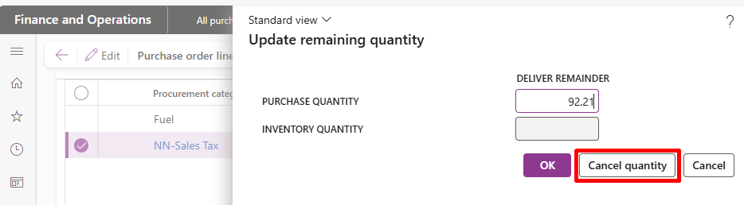

- The system cancels all remaining quantities on the line, and the status updates accordingly. 