This Quick Reference Guide (QRG) provides users with the steps to generate and review two key financial tracking reports in D365 Finance & Supply Chain Management (F&SCM).

Contents
Open Commitment Status by GL Account Report 1
Outstanding encumbrances report 3

Open Commitment Status by GL Account Report
The Open Commitment Status by GL Account report provides visibility into Purchase Orders (POs) linked to specific General Ledger (GL) accounts in D365 Finance & Supply Chain Management (F&SCM).

Steps to Run the Report:

- Navigate to Procurement and Sourcing > Purchase orders > Purchase order follow-up > Open Commitment Status by GL Account.

- In the report parameters window, complete the fields as needed:
  - From date – Enter the starting PO Order Date to include. Leave blank to include all historical data (optional).
  - To date – Enter the ending PO Order Date to include (required).
  - Financial Dimensions – Enter one or more financial dimensions (Department, Award, Project, Location, Fund, or Division).
NOTE: At least one dimension must be selected.

- Set the Confirmed POs only toggle to Yes to display only confirmed Purchase Orders.
NOTE: This excludes approved purchase orders.

- Click OK to run the report.
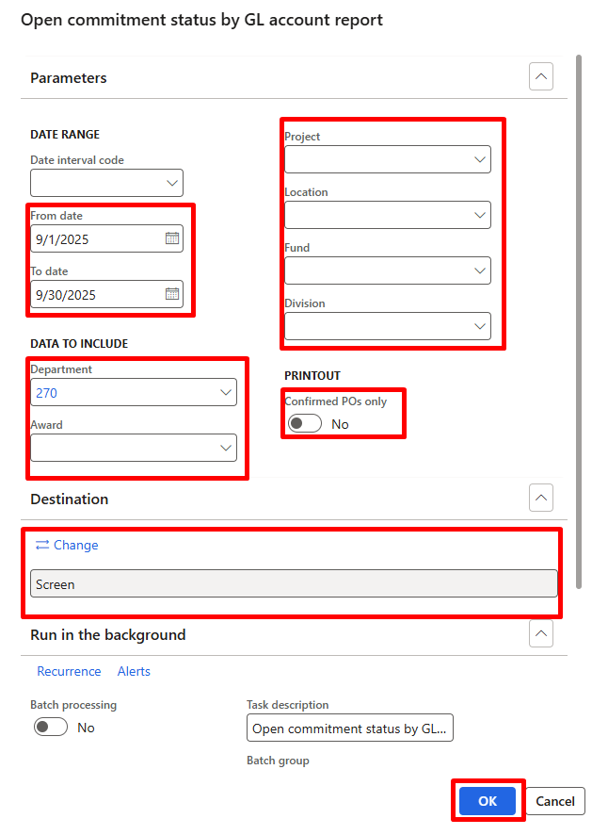

- The report will open in the set print destination (default is Screen).
NOTE: You can change the destination or use Export options once the report is displayed. 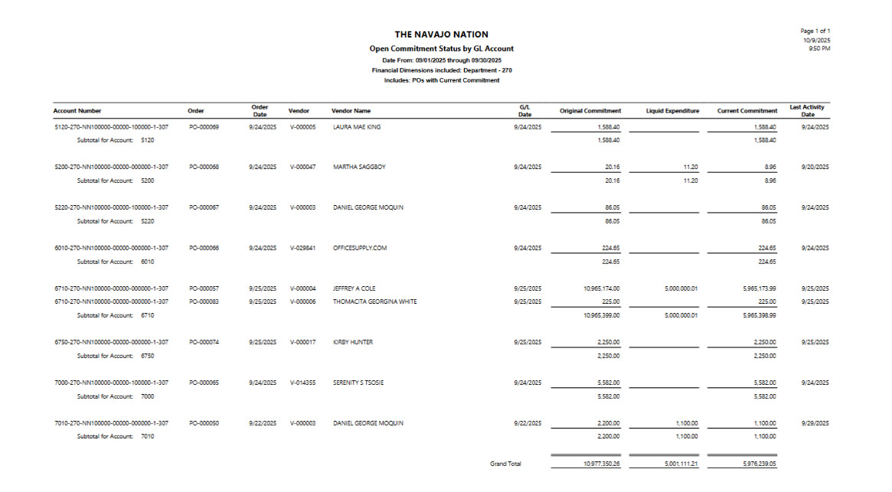

Outstanding encumbrances report
The Outstanding Encumbrances Report provides visibility into open encumbrances — amounts that have been committed to purchase orders but not yet invoiced or liquidated.

It helps finance and procurement teams:
- Monitor remaining obligations against budgets.
- Ensure accurate financial reporting at month-end or year-end.
- Identify outstanding POs that may need to be closed or reviewed.

Steps to run the report:

- Navigate to General ledger > Inquiries and reports > Outstanding encumbrance by financial dimension.
- In the report parameters window, complete the fields as needed:
  - Primary Financial dimension set: Select the dimension set to filter by.
  - From / To dates: Define the reporting period.

- Set the Output destination (Screen, PDF, Excel, etc.).
- Click OK to generate the report. 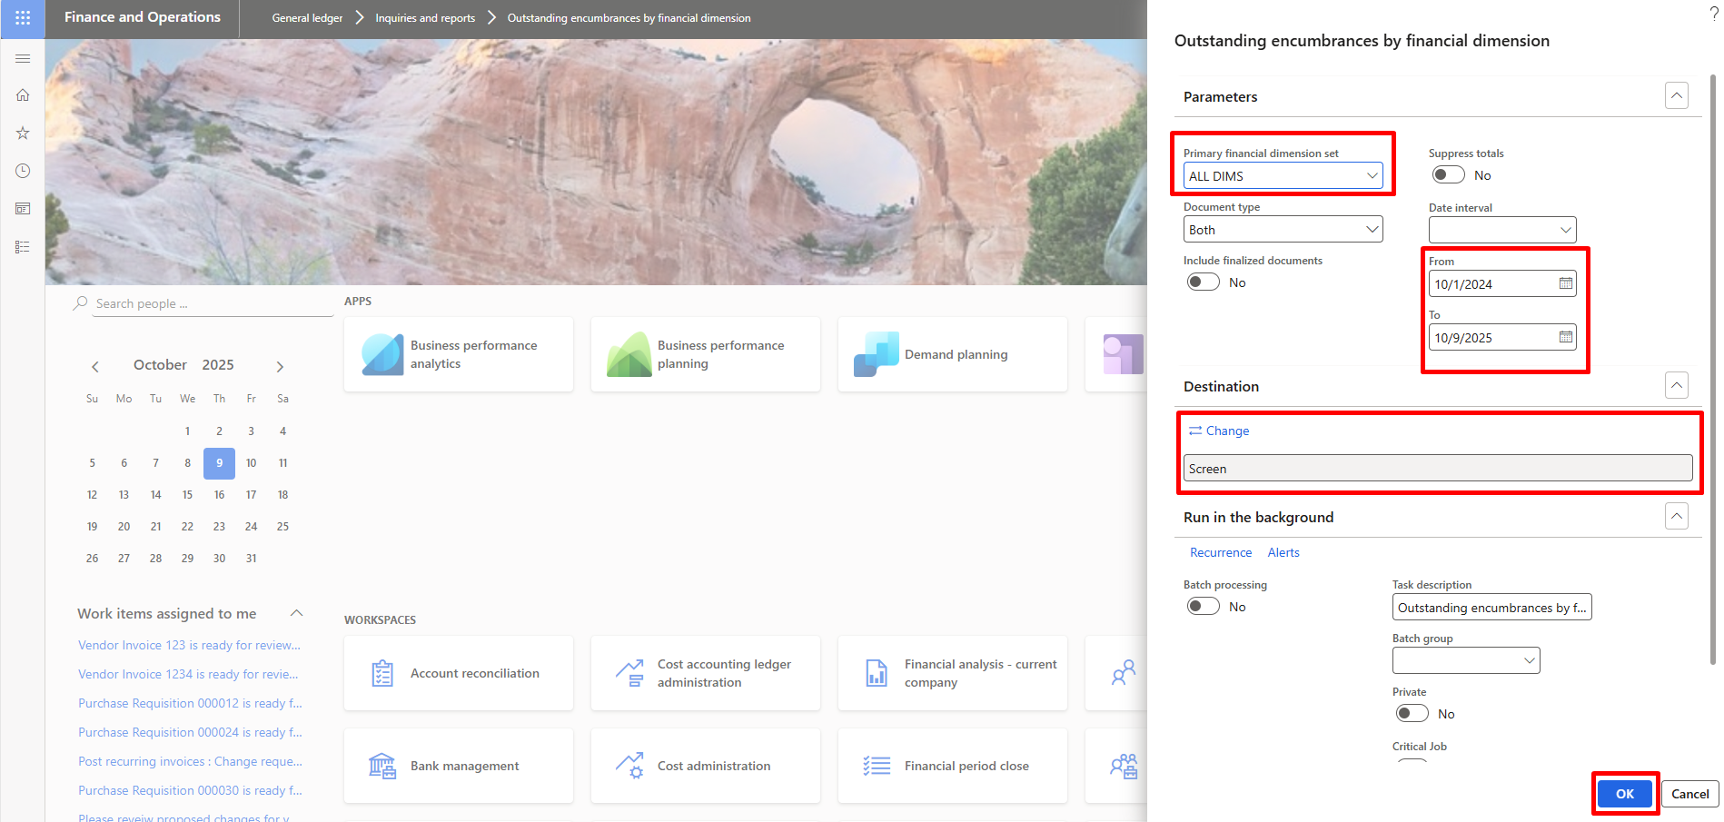

To review the report results:

- The report lists open purchase orders, showing:
  - Original encumbered amount
  - Liquidated (invoiced) amount
  - Remaining encumbrance (still outstanding)
