This Quick Reference Guide (QRG) explains how to record the receipt of goods or services against a Purchase Order (PO) in D365 Finance & Supply Chain Management (F&SCM). The product receipt process confirms that items have been delivered, updates inventory or expense accounts and prepares the PO for vendor invoice matching.

Contents
Revision History 1
Receive a Purchase Order 1
Attach a Receipt to the Product Receipt 3
Cancel Quantities before Receiving a Purchase Order 4

Revision History

Date | Author | Comments
10/28/2025 | Andrea Garay | Original draft
06/08/2026 | Andrea Garay | Added section: Attach a Receipt to the Product Receipt

NOTE: A Purchase Order must be Confirmed before a product receipt can be posted.
A Product Receipt in D365 F&SCM is the process of recording that goods or services ordered on a Purchase Order have been received. It confirms delivery, updates inventory or expense accounts, and allows the vendor invoice to be matched against what was actually received.

Receive a Purchase Order
- Navigate to Procurement and sourcing > Purchase orders > All purchase orders.
- Open the PO to receive.
- Go to the Receive > Generate > Product receipt.
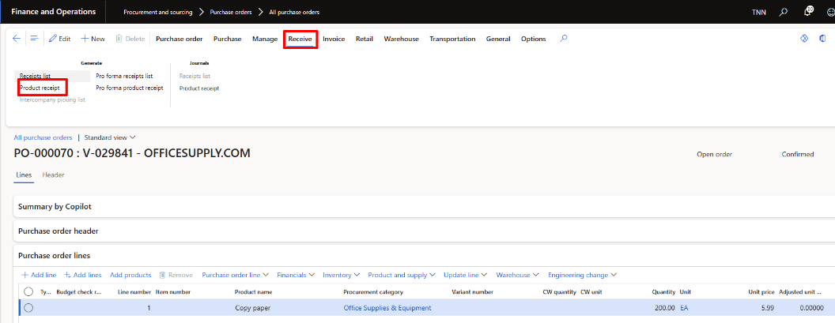

- In the Posting product receipt, scroll down to the the Overview section.
  - Enter a Product receipt number.
  - Enter a Document date.
  - Enter Terms of payment (Optional). 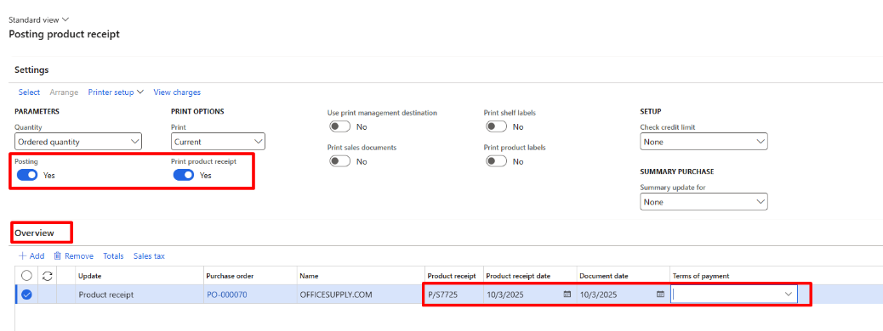

- The Receiving Quantities can be entered in the Lines section:
  - Full receipt: If you received the full quantity, click OK.
  - Partial receipt:
    - On the Lines FastTab, in the Quantity field, enter the amount received. The remaining quantity is calculated automatically.
    - Click OK.
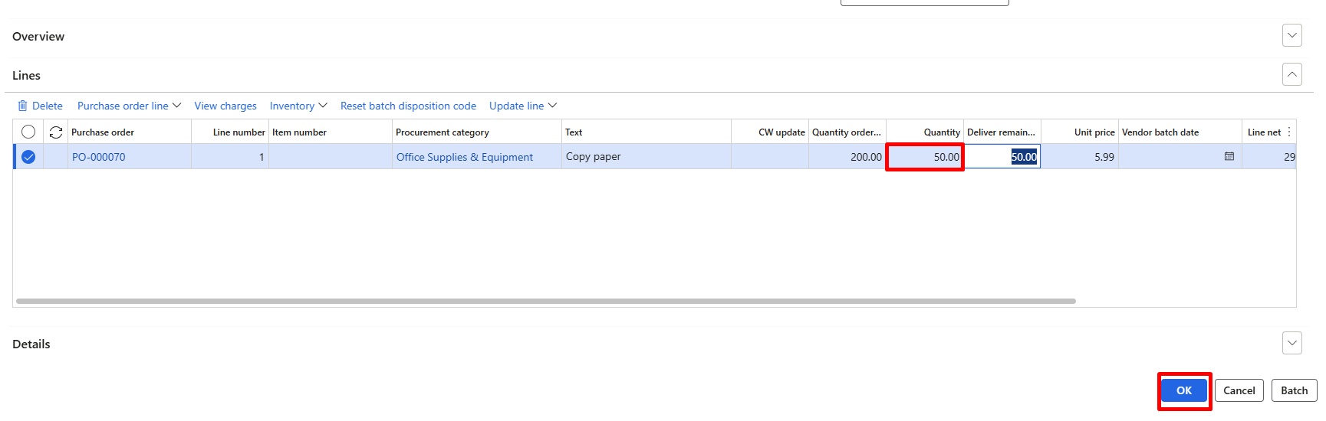
    - You may also delete lines for items not yet received. When those items arrive, create a new product receipt for them.
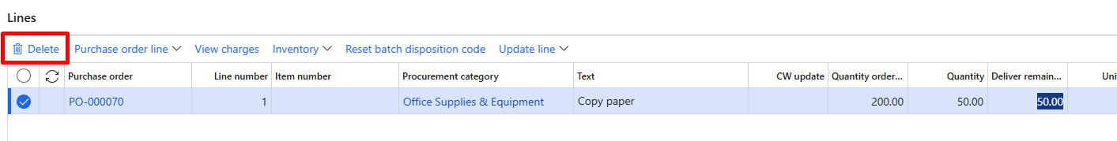
Confirmation & Status
- If successful, you will see an “Operation completed” message in a blue bar.
- The PO status changes to Received once fully received.
- If only a partial quantity is received, the PO status remains Open order until all items are received.

Attach a Receipt to the Product Receipt
After the Product Receipt has been posted, attach the signed receipt, packing slip, or other supporting documentation to the Product Receipt record.
- Navigate to Procurement and sourcing > Purchase orders > All purchase orders.
- Open the Purchase Order and select the Receive tab.
- Click Product receipts and select the posted Product Receipt.
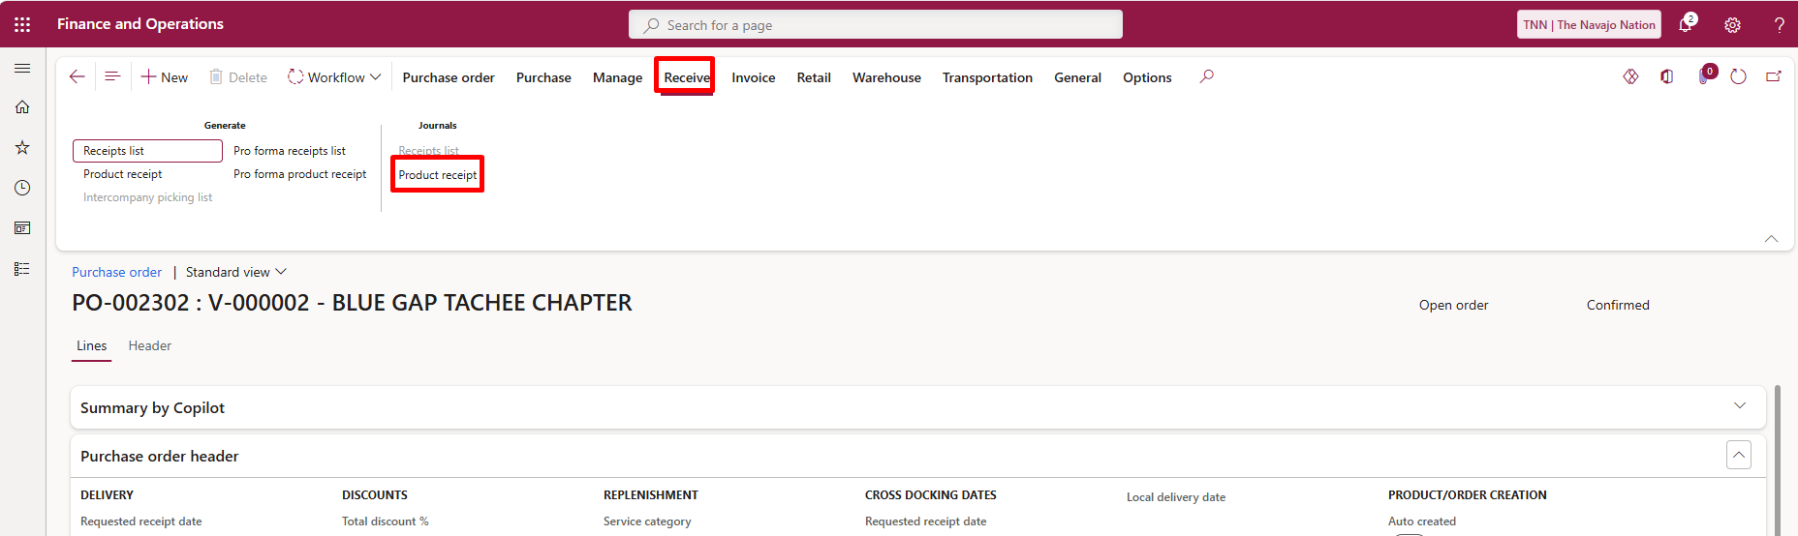
- Open the Product Receipt record.
- Click the Paperclip (Attachments) icon in the upper-right corner of the page.
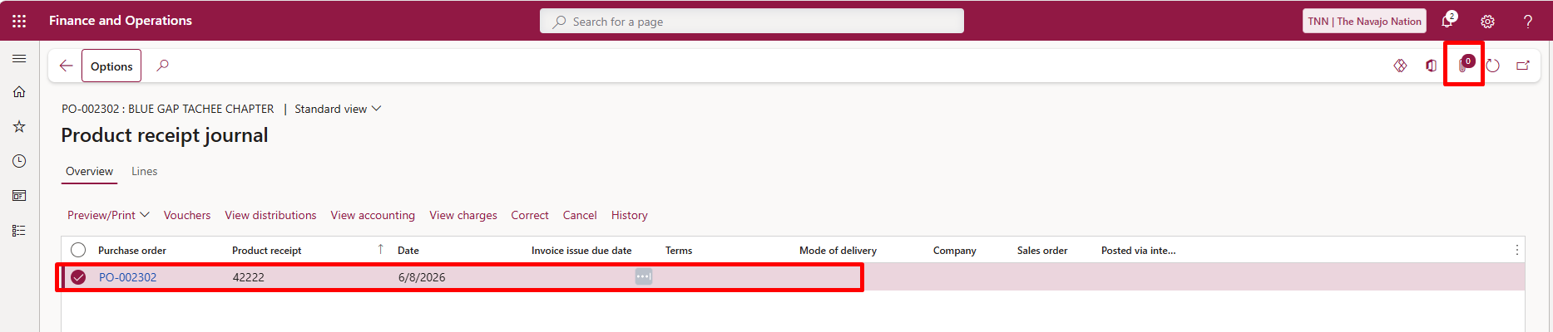
- Click + New and select File.
- Click Browse to locate the receipt document, click OK.
- Close the Attachments window to save the attachment.
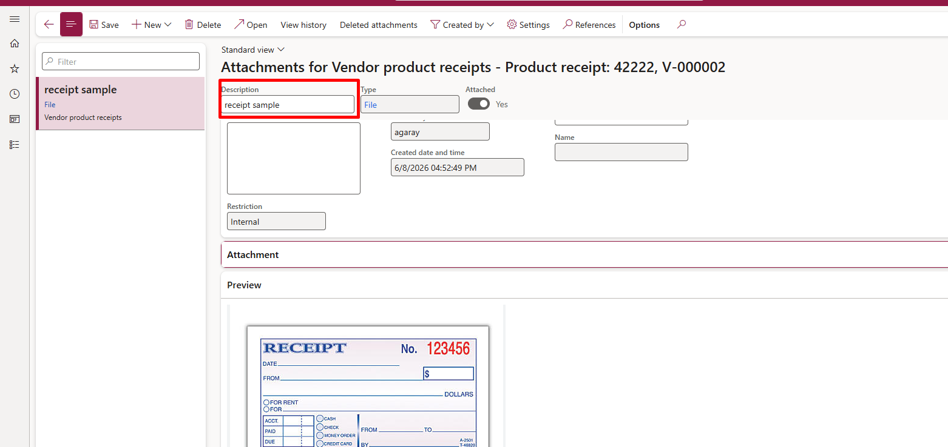
Note: Receipts and supporting documentation must be attached to the posted Product Receipt immediately after receipt posting to ensure proper documentation is available for invoice processing and audit purposes.

Cancel Quantities before Receiving a Purchase Order
- Navigate to Procurement and sourcing > Purchase orders > All purchase orders.
- Open the PO to update and receive.
- On the Purchase order lines FastTab, select the line where you need to cancel quantities. Go to General > Related information > Line quantity.
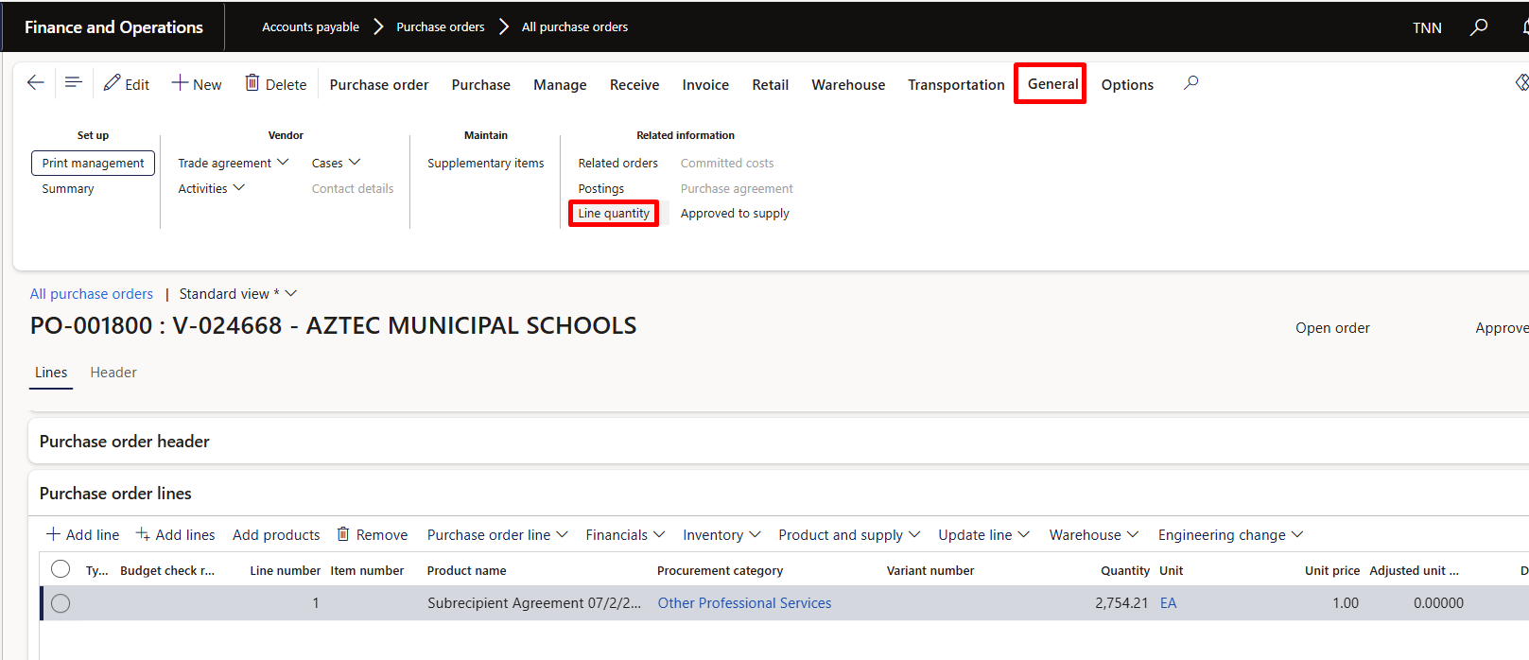
- Review Current Quantities in the Line quantity form, review the following fields:
  - Ordered quantity – Total quantity on the PO.
  - Received quantity – What has already been received.
  - Deliver remainder* – Quantity remaining to be received or canceled.
*The Deliver remainder field represents what’s still open for receipt and this is the quantity the user can cancel.

To cancel the Remaining Quantity on a Purchase Order:

- Click Update line > Update > Deliver remainder.
- In the Update remaining quantity form, click Cancel quantity.
- Confirm the cancellation by clicking OK. 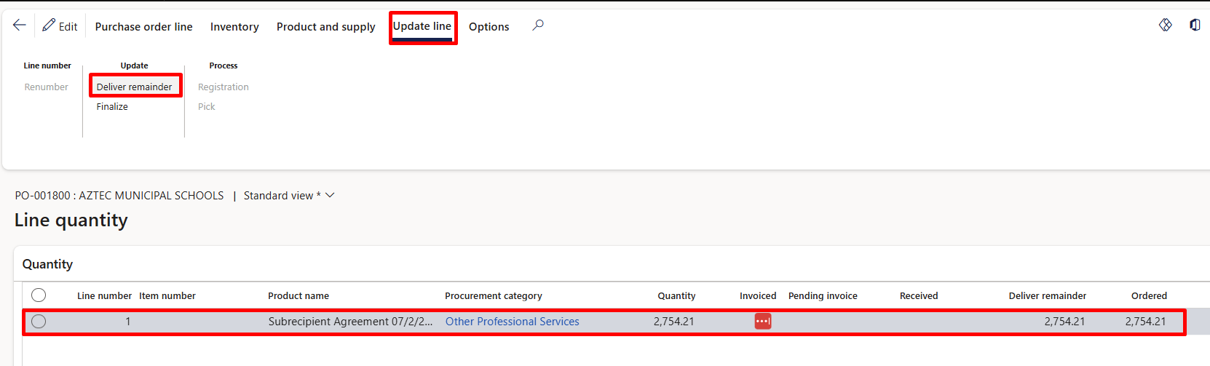

To partially cancel the Remaining Quantity on a Purchase Order:

- Click Update line > Update > Deliver remainder.
- In the Update remaining quantity field, enter the quantity still expected to be received.
- Click OK.
In the example below, we are expected to receive 2,000 quantities out of the 2,754.21 ordered.
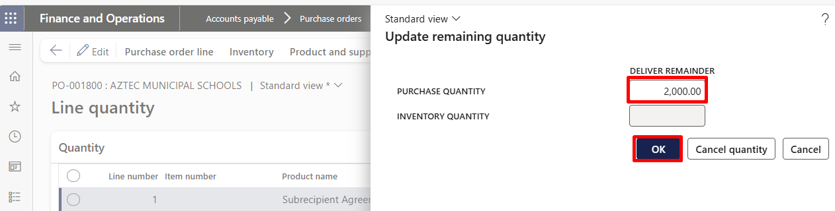

The Deliver remainder is set to 2,000 and ready to receive. Use steps above to receive the updated Purchase order quantity.

