This Quick Reference Guide (QRG) explains the actions users take once a Purchase Order (PO) has been automatically created from an approved requisition in D365 F&SCM. At this stage, all approvals are already complete, so users must avoid changing line details. Instead, the focus is on reviewing the PO, assigning the buyer, verifying delivery information, confirming the order, and generating the vendor copy.

Contents
Revision History 1
Purchase order status 2
Open a Purchase Order 2
Assign a Buyer to the Approved PO. 3
Review/change Delivery Address 3
Purchase Order Workflow 4
Confirm the Purchase Order 5
Printing a Purchase Order 6
Finalize Purchase Order (only after is fully received or cancelled) 7

Revision History

Date | Author | Comments
10/28/2025 | Andrea Garay | Original draft
5/27/2026 |  | Updated the Open a Purchase Order section:  - Added #3 and #4 to From the All purchase orders menu to allow the option to Request change  Added Purchase Order Workflow section

Purchase Orders (POs) are automatically generated once a Purchase Requisition (PR) has been fully approved and closed. This ensures that all required department approvals are completed before the PO is created. Purchase Orders inherit information from the approved requisition. If updates are required prior to PO confirmation, users must select Request Change and resubmit the Purchase Order through workflow. Requisitioners should not make any changes to the approved purchase order lines nor adding new lines. In the case of any changes to the purchase order lines, the purchase order will need to be re-submitted for additional review and approval.

Purchase order status
POs include several status fields that indicate the progress of the order. The Purchase order status field shows the status for quantities on the order.

Status | Description
Open Order | The PO is approved/confirmed but items or services have not yet been received.
Received | Items or services on the PO have been received* (partially or fully).  *Only Open Order or received status allows for the invoicing of the PO.
Invoiced | The vendor’s invoice has been matched to the PO (partially or fully).
Closed | The PO is fully received and invoiced; no further activity is expected.
Canceled | The PO or specific lines were canceled and will not be processed.

Open a Purchase Order
From the closed Purchase Requisition:
- The user can drill down to the Purchase Order by clicking on the PO number generated from the closed Purchase Requisition. 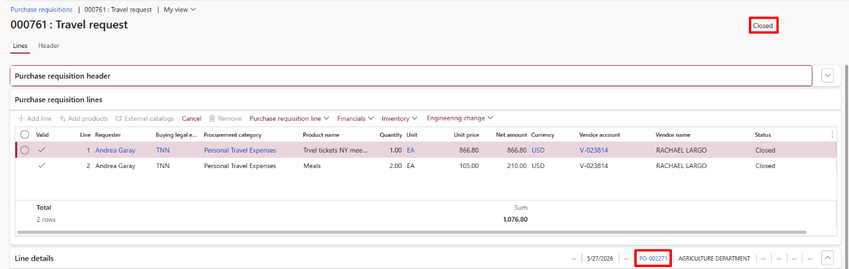

From the All purchase orders menu:
- Navigate to Procurement and sourcing > Purchase orders > All purchase orders.
- Locate the PO that was generated from the closed requisition.
NOTE: Purchase Order gets created with Approved status.

- Open the Purchase Order, and click Request Change in the Purchase Order tab 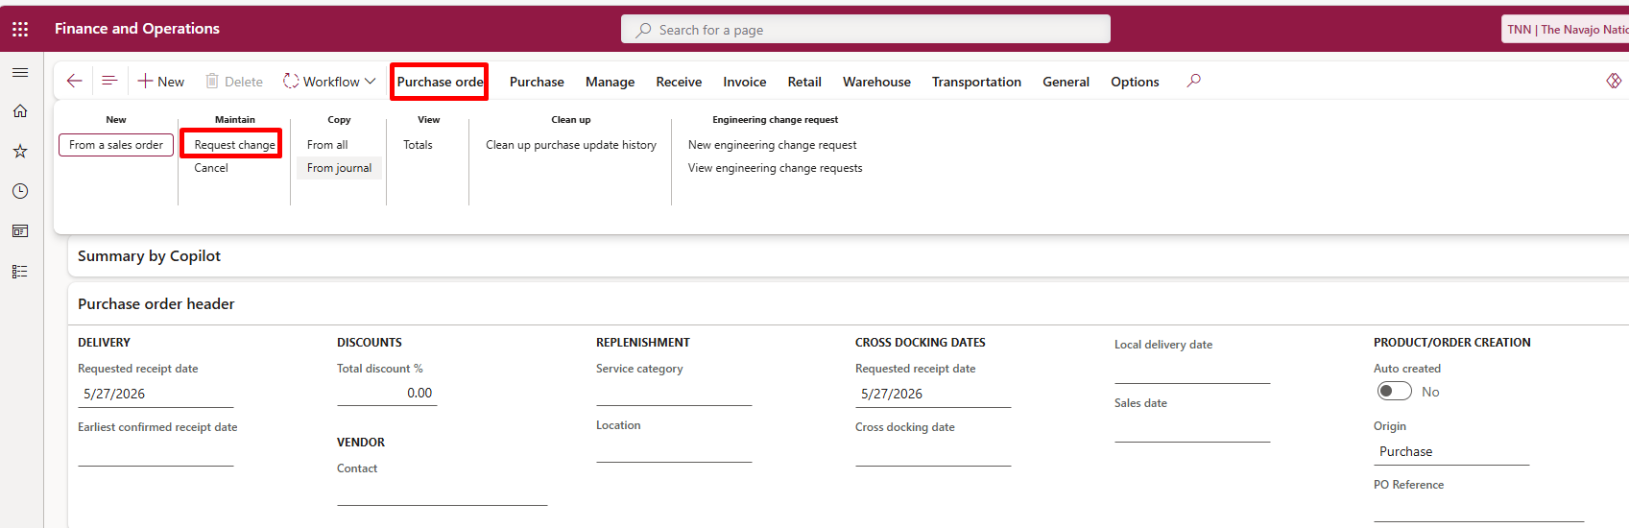
- This will change status of the PO to “Draft” for changes to PO header.

Assign a Buyer to the Approved PO.
- Open the Purchase Order.
- Click to open the Header tab and open the Setup FastTab.
- Select the Orderer (Buyer) from the dropdown. 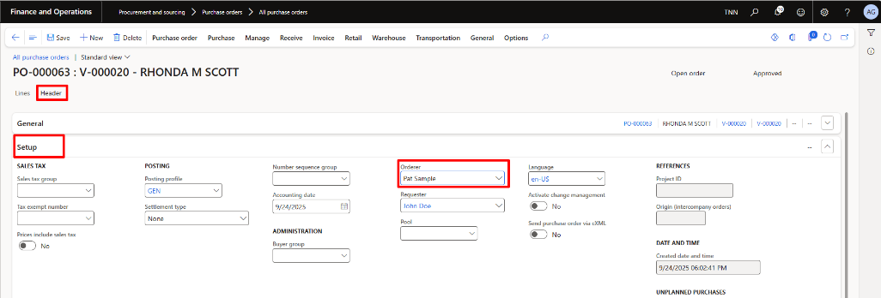

Review/change Delivery Address
- Open the Address tab, confirm the Delivery address.

To change the delivery address:
  - Click to open the other addresses. 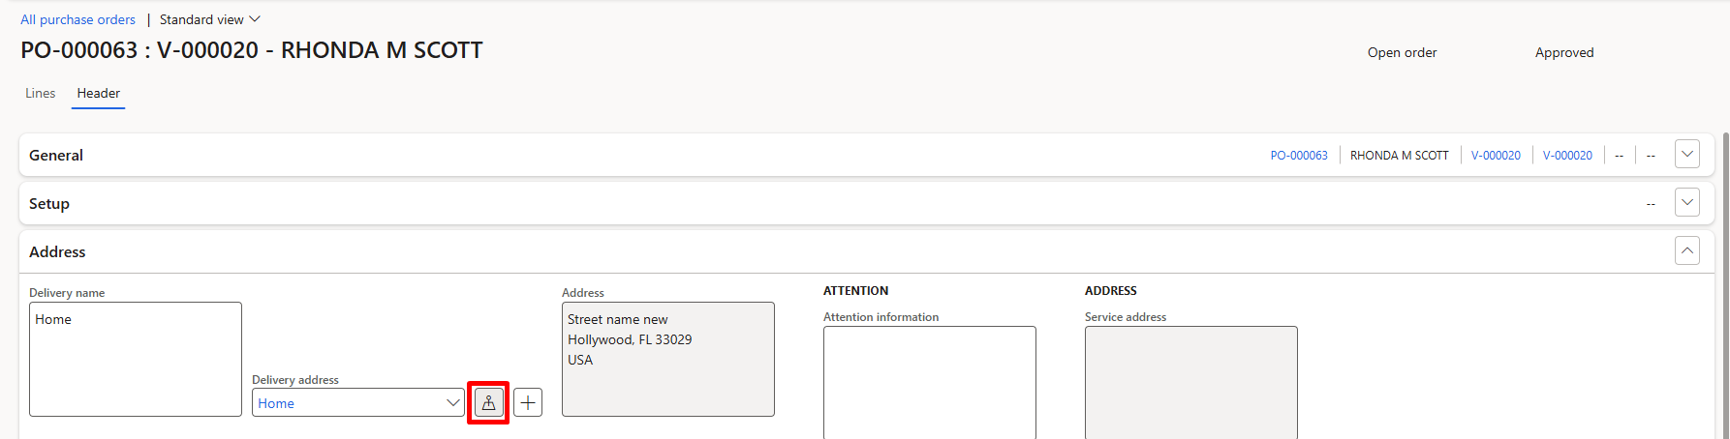

  - Select Companies from the Address selection dropdown
  - In the ADDRESS section, select the delivery address as needed. 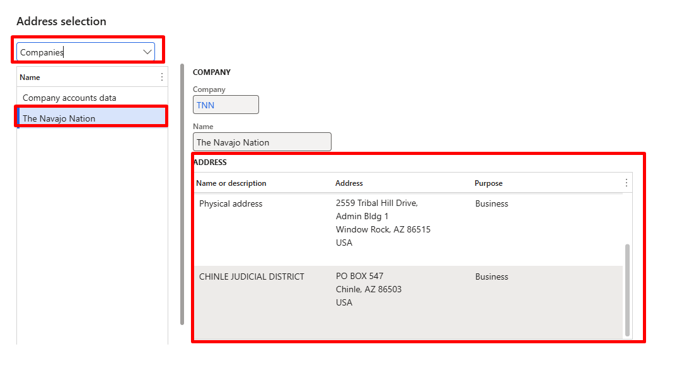
  - Click OK.
  - System will warn the user to update delivery address to all purchase order’s lines, click Yes to all.
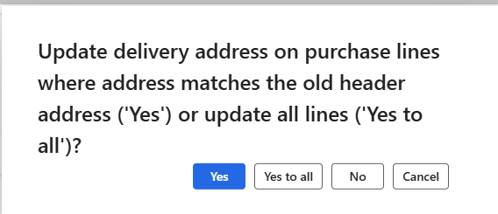

NOTE: Delivery address will print as the Ship to Address on the Purchase Order.

Purchase Order Workflow
Modifying key financial or purchasing information on the Purchase Order will trigger an additional Procurement Review workflow approval.

The Purchase Order will auto-approve if no changes are made to the following fields after the Purchase Order is created:

- Procurement Category
- Quantity
- Unit Price
- Net Amount
- Accounting Distributions
- PO line descriptions

If changes are made to any of the fields listed above, the Purchase Order will be submitted for re-approval.

Submit Purchase Order to Workflow
- Review the Purchase Order changes.
- Confirm all required information is complete and accurate.
- Select Workflow > Submit.
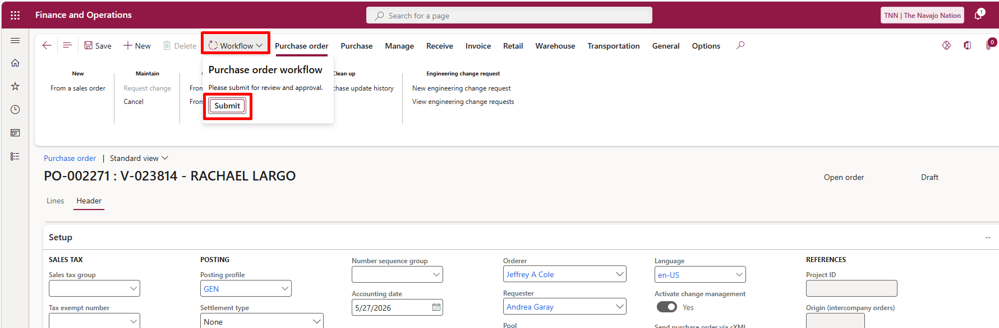
- Enter comments if needed.
- Click Submit to route the Purchase Order for approval

Confirm the Purchase Order
PO Confirmation is the step where an approved purchase order is formally finalized in the system. When the PO is Confirmed:

- The system locks in the order details (vendor, quantities, prices, delivery, accounting).
- A legal purchase commitment is created.
- The PO document can be printed or sent to the vendor (depending on setup).
NOTE: Once confirmed, the PO’s Document status changes to Confirmed.
.

To confirm a Purchase Order:
- On the Action Pane, click Purchase > Actions > Confirm. 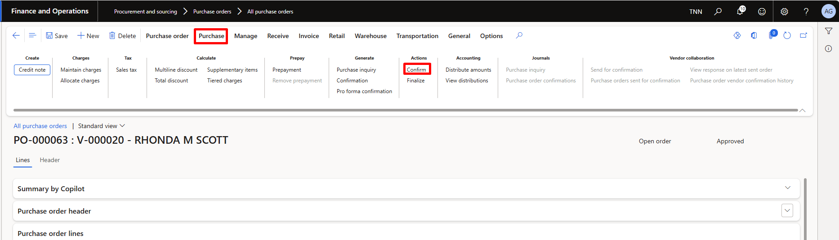
- The purchase order status changes to confirmed and the PO can be printed or sent out to the vendor. 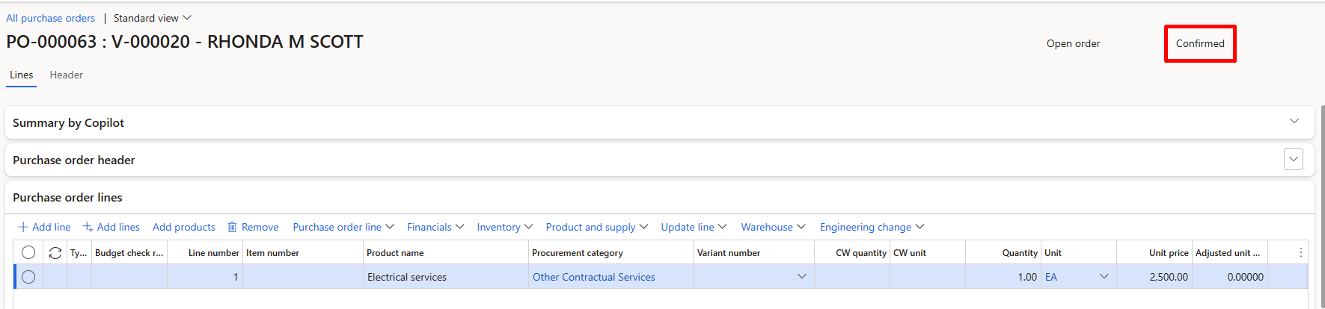

Printing a Purchase Order
- On the Action Pane, click Purchase > Journals > Purchase order confirmations.
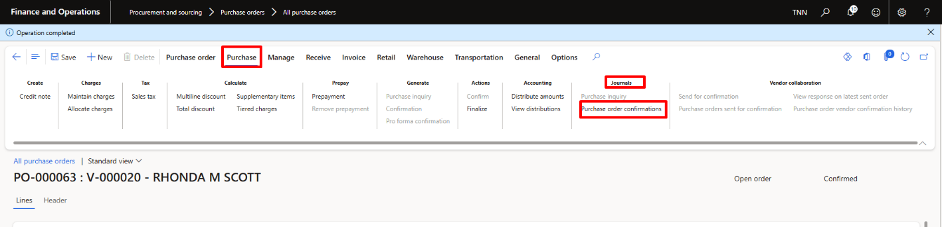
- On the Purchase order confirmations form, select the PO > Preview/Print.
- Select either Copy preview or Original preview. 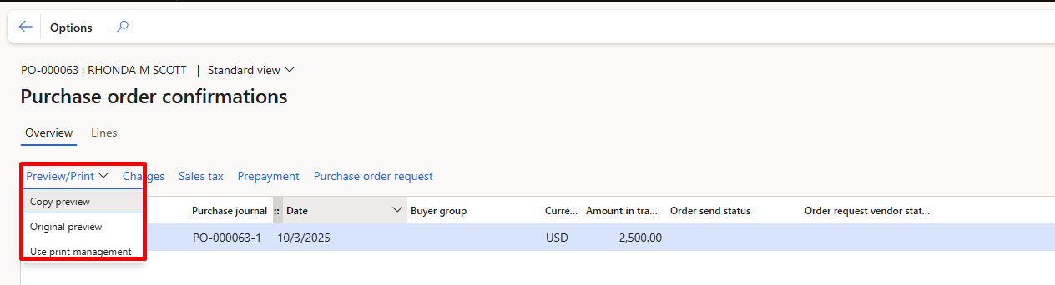
- Purchase Order prints out to the selected destination. 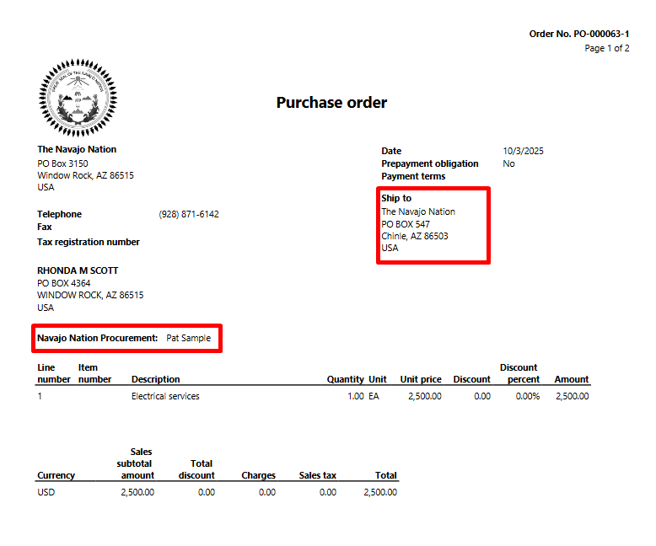

Finalize Purchase Order (only after is fully received or cancelled)
The last step of a PO processing after the invoice is generated is to finalize a PO. This action will release any budget and encumbrance reservations against this PO, close the PO and all related activities to prevent users from modifying it.

To finalize a Purchase Order:
- Navigate to Procurement & Sourcing > Purchase Orders > All Purchase Orders
- Select the PO you want to finalize.
Note: only POs that are in status “Confirmed” and “Invoiced” or “Cancelled” can be finalized. Otherwise, the red bar and error message will be displayed
- Click Purchase > Actions > Finalize.
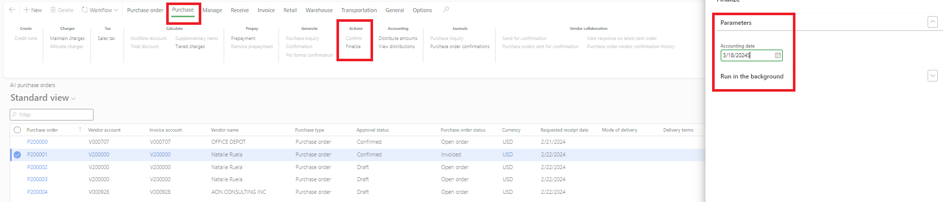
- Select the date of closure (defaulted to current date).

- The Purchase Order will now have a status “Finalized” and the blue bar will indicate that the operation is completed successfully.
