This Quick Reference Guide (QRG) outlines the responsibilities of approvers in the Purchase Requisition (PR) workflow in D365 Finance & Supply Chain Management (F&SCM). Approver’s role includes Department Heads, Directors, etc. The workflow route is determined by Business Reason and purchase thresholds entered by the originator.

Contents
Logging in to D365 FSCM 1
F&SCM Chart of Accounts Structure 2
How Posting Works in D365 F&SCM 2
Purchase Requisition workflow 3
Purchase requisitions statuses 4
Understanding Budget Control and Purchase Requisitions 5
Viewing Budget Control Statistics 6
Purchase Requisitions approval 7
To View Purchase Requisitions attachments 8
To add an attachment to the Purchase requisition 9
Take Action in Requisition Workflow 10
Review Workflow History 10
Enable Workflow Notifications 10

Revision History

Date | Author | Comments
10/28/2025 | Andrea Garay | Original draft
06/08/2026 | Andrea Garay | Upadated section Purchase Requisition workflow:  - Added the updated workflow diagram

Logging in to D365 FSCM
SAT (Test/Training) Environment
- Open Google Chrome or Microsoft Edge.
- In the address bar, enter the SAT environment link:
- https://nn-sat2.sandbox.operations.gov.microsoftdynamics.us/?cmp=TNN&mi=DefaultDashboard
- When the login page appears, enter your Office 365 credentials.
- If prompted, complete multi-factor authentication (MFA).
- Once logged in, you will see the D365 home page.
First Login Tips
- Bookmark the SAT link for quick access later.
- If you receive an error, clear your browser cache and retry.
- Always use Chrome or Edge (do not use Internet Explorer).

F&SCM Chart of Accounts Structure
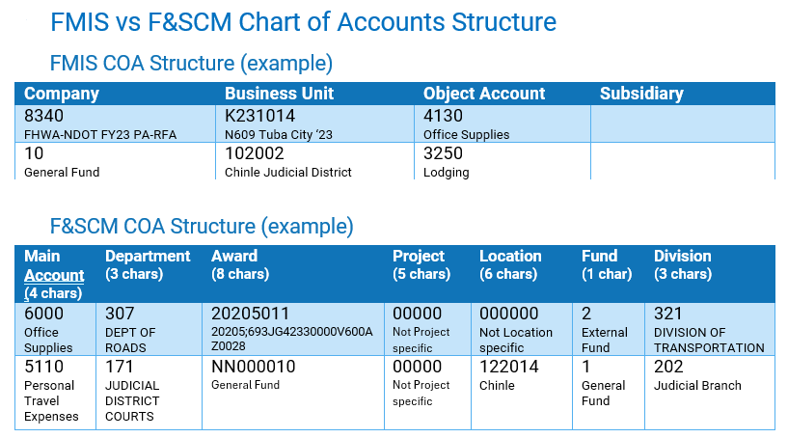

How Posting Works in D365 F&SCM
- D365 requires a full account string for every transaction to post to the ledger.
  - A full account string = Main Account + Financial Dimensions.
- Where the pieces come from:
  - Main Account → comes from the Procurement category.
  - Financial Dimensions → usually manually entered.
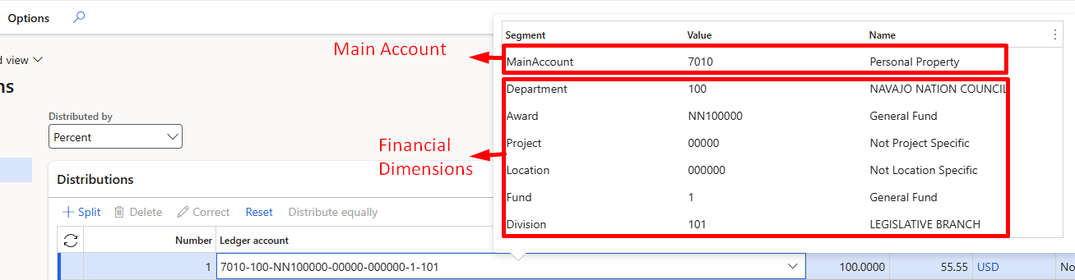

Purchase Requisition workflow
High-level process below:
- Requisition is submitted for approval.
- If under $10,000 → Purchase Order is created automatically.
- The system then checks the Business Reason, which determines the workflow route
(e.g., Goods, Service Contract/Subrecipient, Direct Payment).
- Based on the Business Reason, the workflow continues through the appropriate approval path.
- The system then evaluates the Funding Source:
  - General Funds
  - External Funds
- If External Funds AND over $50,000 → Contract Accounting approval is required.
- Additional approvals (Program, Procurement, Buyer, Accounting, etc.) are based on:
  - Business Reason
  - Funding type
  - Dollar thresholds
- Once all required approvals are completed, the process moves forward to full PO processing.
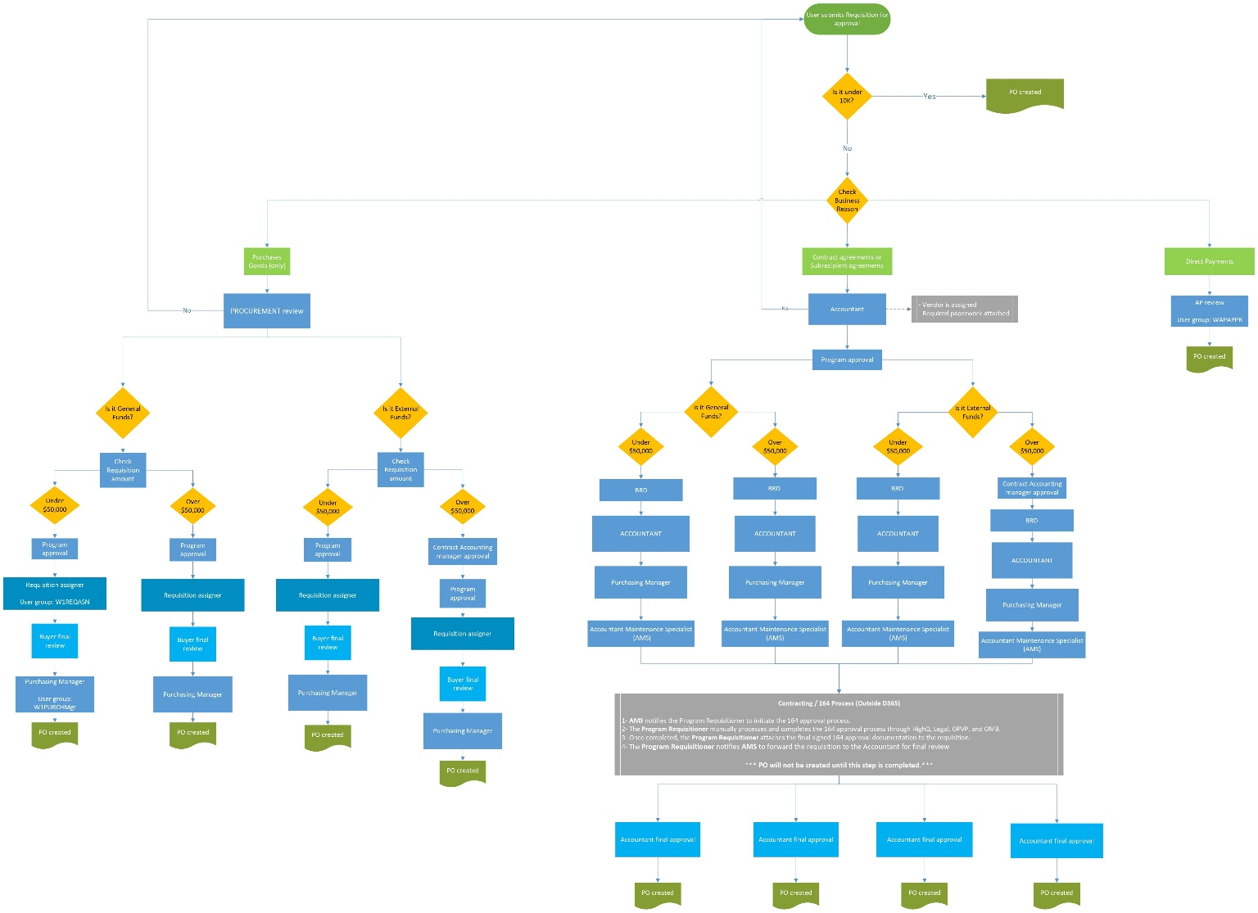

Purchase requisitions statuses
Status | Description
Draft | The requisition has been created but not yet submitted. Users can edit lines, update details, and save changes.
In Review | The requisition has been submitted to workflow. Awaiting approval from one or more approvers.
Rejected | An approver has rejected the requisition. It must be corrected and resubmitted for review.
Approved | The requisition has passed workflow approvals.
Closed | The requisition is finalized. Typically, when it has been converted to a PO.
Canceled | The requisition has been withdrawn/canceled and will not be processed.

Understanding Budget Control and Purchase Requisitions
The following financial dimensions are used for budget control:
- Department
- Award
- Project

When Is Budget Control Checked?
Budget control is evaluated at multiple points in the procurement process:
- When entering or editing purchase requisition lines
- When updating accounting distributions
- When submitting a requisition to workflow
- When approving a requisition

Important: A requisition may pass budget control at entry but fail later if budget availability changes.

Budget Control Indicators
Budget status is displayed using visual indicators on the purchase requisition line and during workflow actions.

Indicator | Meaning | Action Required
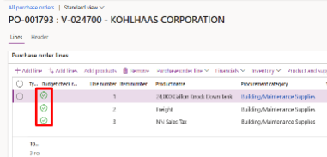 | Budget is available | OK to approve.
⚠️ Warning | Budget exceeded but allowed | Review and justify; approval decision required
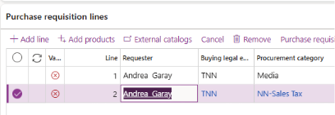 | Budget exceeded and blocked | Funding must be corrected before approval

To view from Budget check errors or warnings:

- Open the Purchase Requisition.
- Navigate to the Financials > Budget check errors and warnings.

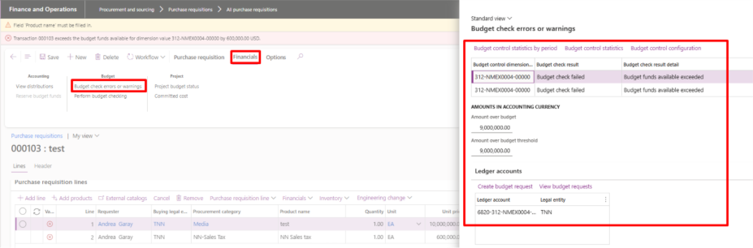
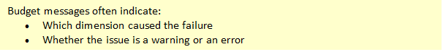

Viewing Budget Control Statistics
Control statistics provide a detailed breakdown of budget availability.
To view Control Statistics:
- Open the Purchase Requisition.
- Navigate to the Financials > Budget check errors and warnings.
- Click Control statistics.
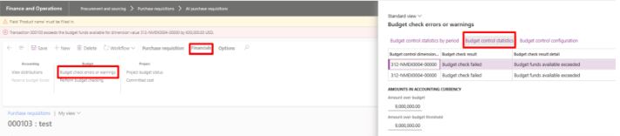
- Make sure budget cycle for the current fiscal year is selected, click Apply parameters. 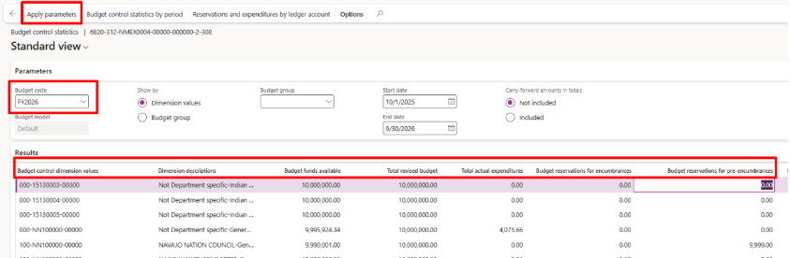

What Control Statistics show:
Columns | Meaning
Budget funds available | Remaining available budget
Total revised budget | Original budget
Total actual expenditures | Actual expenses
Budget reservations for encumbrances | Confirmed Purchase orders
Budget reservations for pre-encumbrances | Approved Purchase requisitions

Purchase Requisitions approval

When a requisition is submitted for approval, you will be notified in three places:
- Action Center – if enabled for your user (see instructions below), notifications appear in the top right of the screen.
- Work items assigned to me – on your D365 home page, showing pending tasks.
- Emails – based on email configuration.

From Action Center:
- Click the notification in the Action Center.
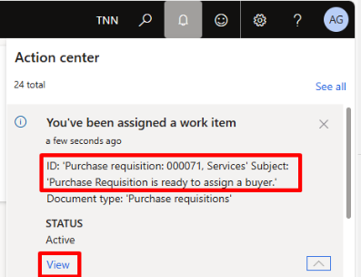
- The system opens the requisition directly for review.

From Home Page (Work items assigned to me):
- On the home page, go to the Work items assigned to me section.
- Select the requisition from the list to open it. 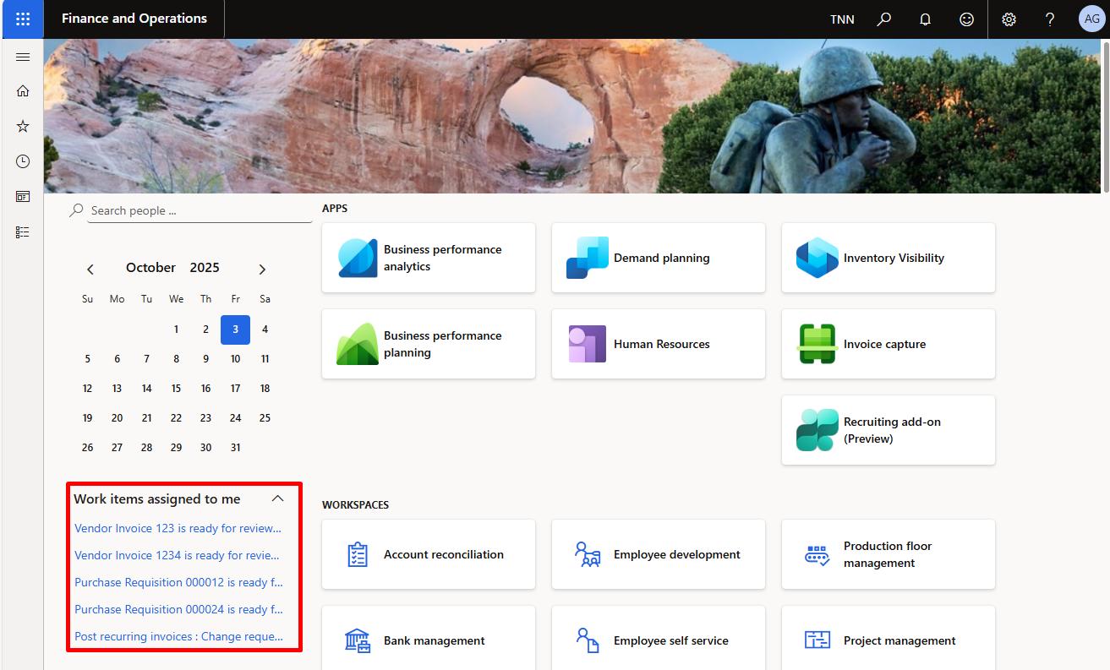

To Open from Purchase Requisitions Menu
- Navigate to Procurement and sourcing > Purchase requisitions > Purchase requisitions require my action > Purchase requisitions assigned to me.
- Select the requisition to be reviewed and click to open it.

To View Purchase Requisitions attachments

- Navigate to Procurement and sourcing > Purchase requisitions > Purchase requisitions require my action > Purchase requisitions assigned to me.
- Select the requisition you want to review.
- On the Action Pane, locate and click the Attachments (paperclip icon) in the top-right corner of the screen. 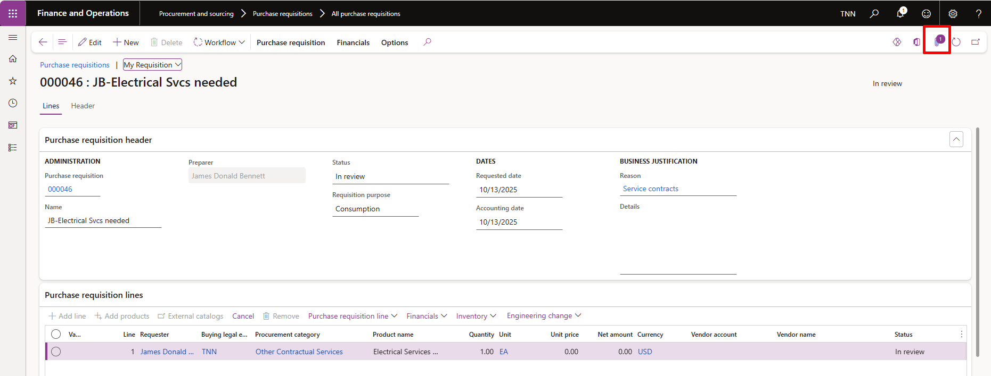

- In the Attachments form:
  - Select the attachment type (File, Note, or URL).
  - Click the File name to open or download the document (e.g., PDF, Word, Excel).
  - Use View > File > Open if prompted.
- Review all attached documents before taking workflow action.
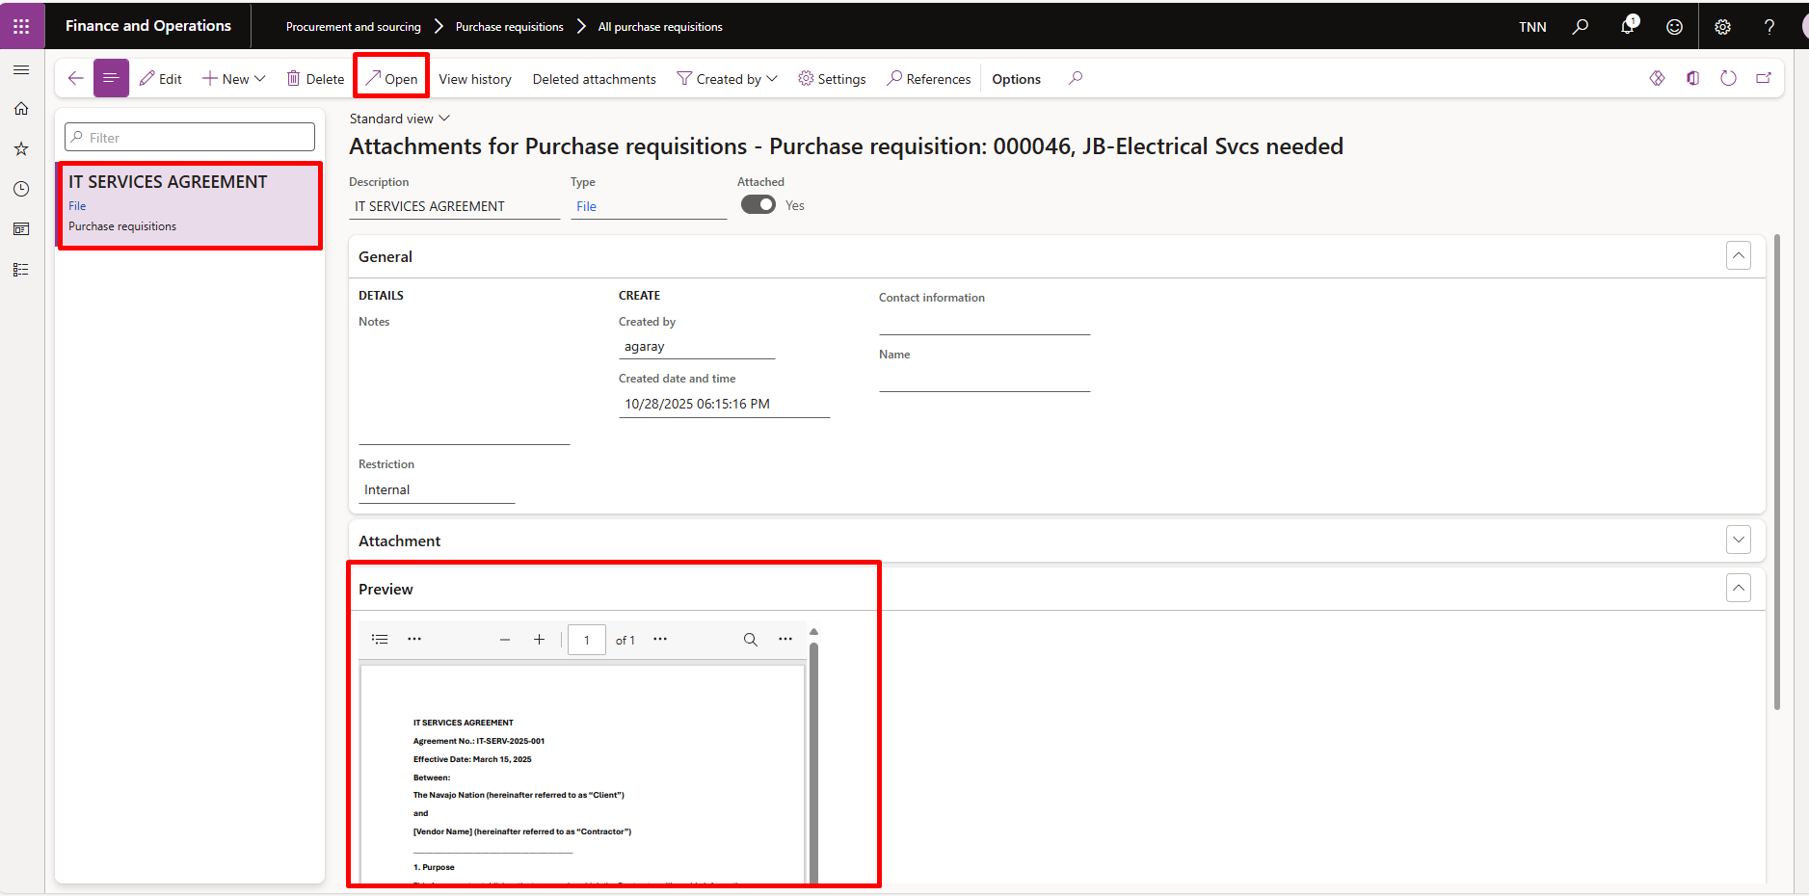
- When finished, close the attachment form to return to the requisition.

To add an attachment to the Purchase requisition line
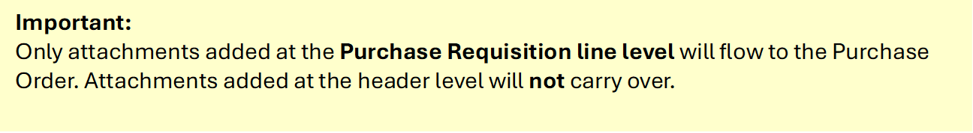
- Select Line 1 on your Purchase requisition lines > Purchase requisition line > Attachments. 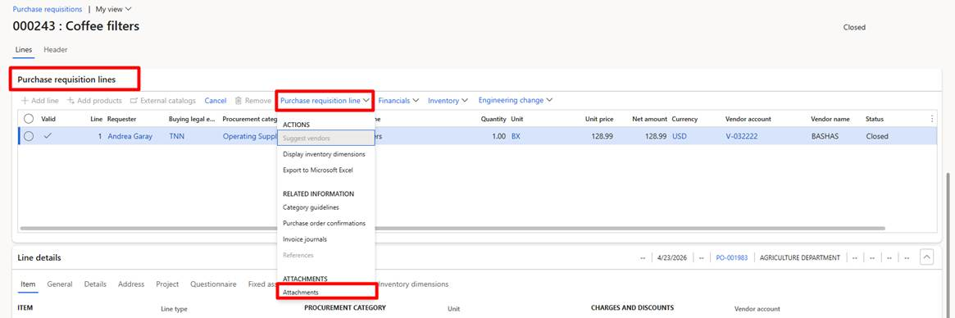
- In the Attachments form, click + New, select the File type.
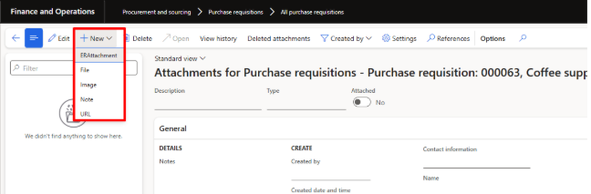

- Browse to upload the attachment.
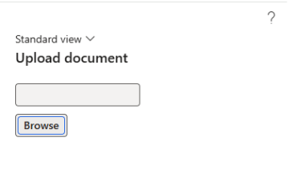
- The file will be uploaded and listed in the attachments grid.
- Close the Attachments form to return to the requisition.

Take Action in Requisition Workflow
Once Requisition is reviewed, click Workflow on the Action Pane, and choose one of the following:
- Approve → Moves the requisition to the next step in the workflow.
- Reject → Stops the process and sends it back to the originator.
- Request Change → Returns the requisition for updates before resubmission.
- Delegate → Assigns the approval task to another authorized approver.

Review Workflow History
- Navigate to Procurement and Sourcing > Purchase requisitions > All purchase requisitions.
- Select and open the Purchase Requisition needed to review.
- On the Action Pane, click Workflow > Workflow history.
- The Workflow history form will open. Here you can view:
  - Workflow status (In progress, Completed, Rejected, etc.).
  - Step-by-step actions taken in the approval process.
  - Approvers’ names and actions (approved, rejected, delegated).
  - Date and time stamps for each action.
  - Comments entered by approvers.
- Expand sections or switch tabs to see more details about each workflow step.
- Close the form when it is finished.

Enable Workflow Notifications
- In the Navigation bar, click the Gear icon (⚙) in the top-right corner.
- Select User options.
- In the User options form, go to the Workflow tab.
- Under Notifications, set the toggles to Yes for the notifications you want to receive:
  - Action center – receive workflow notifications in the Action Center (top-right bell icon).
  - Email – receive workflow notifications email.
- Click Save.

