This Quick Reference Guide (QRG) outlines the responsibilities of the Procurement Department when reviewing and approving Purchase Requisitions (PRs) in D365 Finance & Supply Chain Management (F&SCM). Procurement review is the first workflow step and ensures that requisitions are complete, accurate, and compliant with purchasing policies before moving forward.

Contents
Revision History 1
Workflow Overview 2
Accountant Initial/Final Review for Contracts / Subrecipient Agreement approval 2
Buyer Assignment delegation and approval 3
Special Case – Direct Payments 5
Enable Workflow Notifications 5
Key Takeaway for Procurement Staff 6

Revision History

Date | Author | Comments
10/28/2025 | Andrea Garay | Original draft
04/22/2026 | Andrea Garay | Updated Business Reason  - Changed Service Contract to contracts
05/27/2026 | Andrea Garay | Updated Workflow Overview  - Added new screenshot of the Procurement review functions  - Updated Key Workflow Highlights with roles based on new Procurement workflow

Workflow Overview
The Purchase Requisition workflow in D365 F&SCM routes requisitions through several approval stages depending on the Business Reason and purchase threshold.
In most cases, the Procurement review is always the first step, followed by buyer assignment and approvals.

In the workflow diagram below, red squares highlight the steps performed by the Procurement Department. These include Assigner/Buyer review, Accountant Initial Review.
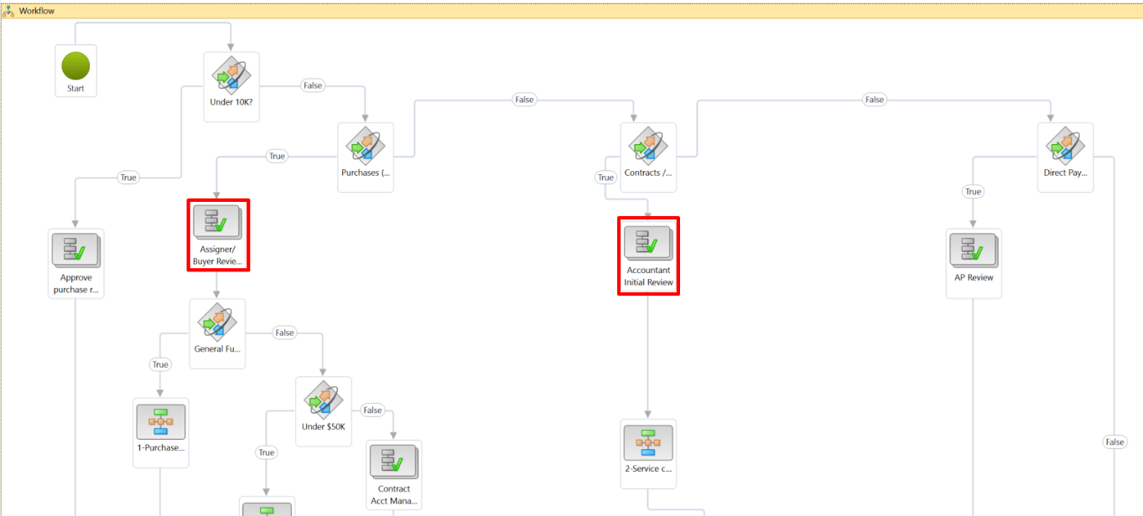

Key Workflow Highlights
- Assigner/Buyer review → Delegate to the correct buyer and record their name in the header.
- Accountant Initial/Final Review → This step is assigned to Accountant in Procurement to verify compliance, attachments, vendor details, etc., for Contracts/Subrecipient agreements requisitions.

Accountant Initial/Final Review for Contracts / Subrecipient Agreement approval
- Business Reason: Contract or Subrecipient Agreement.
- The Accountant Initial Review will receive a notification that a work item has been assigned.
- Click View to open the requisition.
- Review the purchase requisition, then click Workflow > [Select Action]: 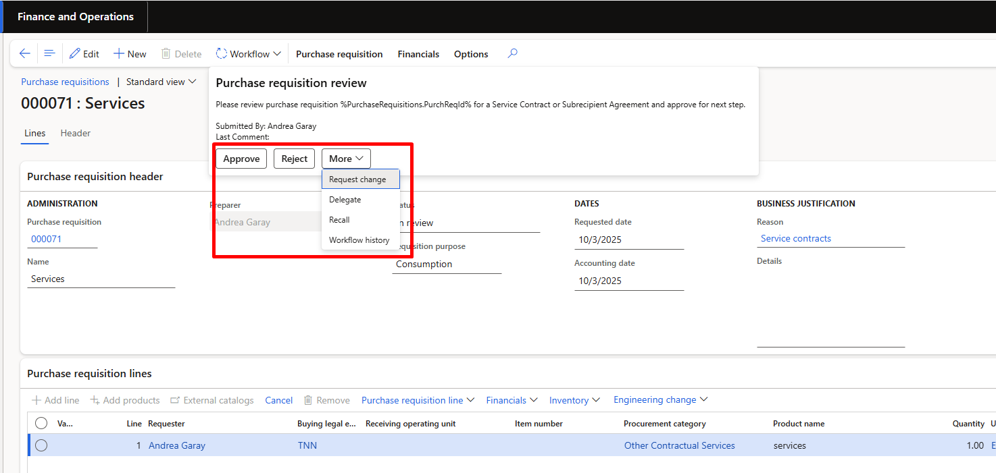
  - Approve → Moves the requisition forward to the next step in the workflow.
  - Reject → Stops the requisition; it is sent back to the originator and cannot continue until resubmitted.
  - Request Change → Sends the requisition back to the originator for corrections; can be resubmitted after changes.
  - Delegate → Reassigns the approval task to another authorized approver.
  - Recall → Available to the originator; pulls the requisition back from workflow to make edits.
  - Workflow history → Displays the approval trail, including status, approvers, actions taken, and comments.

Buyer Assignment delegation and approval
This workflow stage includes two parts:
- The assignment of the requisition to a Buyer
- The procurement/approval work by that Buyer.

To assign the buyer (delegation):
- The user will receive a notification that a work item has been assigned. Click View. 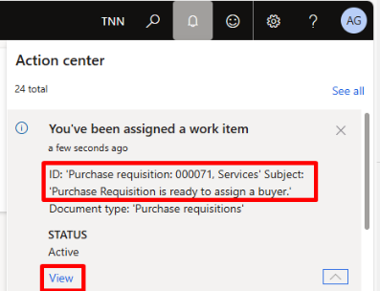
- Open the purchase requisition and click Edit.
  - In the Details field on the requisition header, enter the Buyer’s name. 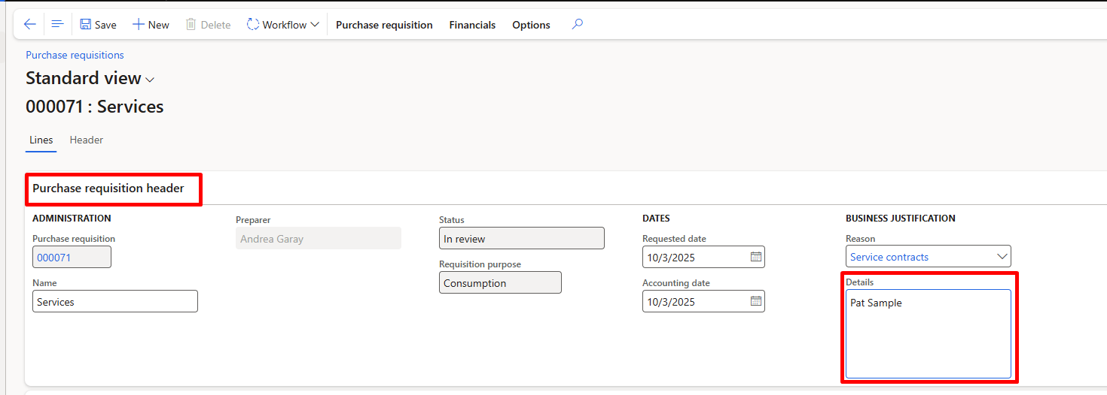
- On the Action Pane, click Workflow > More > Delegate. 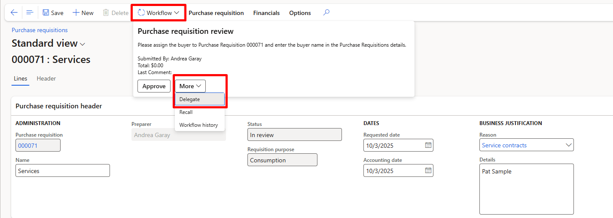
- In the Delegate form:
  - Search and select the User (Buyer) from the dropdown.
  - Enter Comments (Always enter a note to the buyer “RECOMMENDED”).
  - Click Delegate.
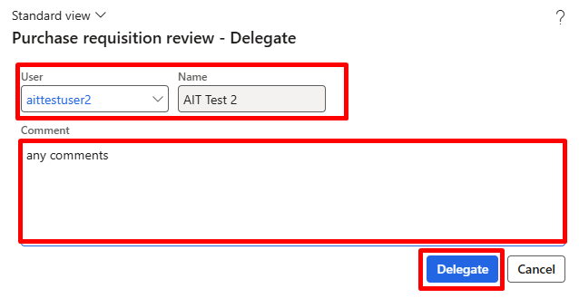
- The assigned Buyer will then continue processing the requisition (e.g., procurement tasks, vendor follow-up, PO creation).

The Buyer Procurement Work & Approval:

- The buyer will receive a notification that a work item has been assigned
- Click View to review the requisition details.
- Perform required procurement tasks (e.g., vendor contact, quotes, etc.).
- Update requisition (if needed).
- Attach any required documentation (quotes, signed contract, justification, etc.) using the Attachments (paperclip icon).
- Once procurement work is complete, click Workflow > Approve. 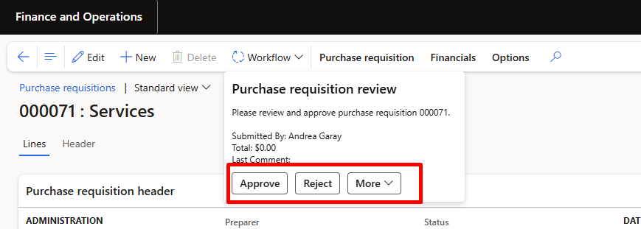
- Enter comments if needed, then click OK.

Special Case – Direct Payments
- Business Reason: Direct Payment.
- These requisitions bypass Procurement and route directly to Accounts Payable for approval.

Enable Workflow Notifications
- In the Navigation bar, click the Gear icon (⚙) in the top-right corner.
- Select User options.
- In the User options form, go to the Workflow tab.
- Under Notifications, set the toggles to Yes for the notifications you want to receive:
  - Action center – receive workflow notifications in the Action Center (top-right bell icon).
  - Email – receive workflow notifications in the email.
- Click Save.
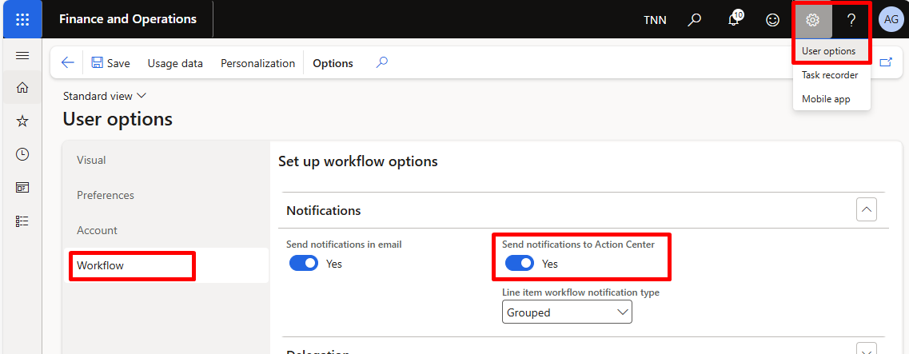

Key Takeaway for Procurement Staff
- Always check Business Reason, Vendor, Attachments, and Thresholds.
- Assign or delegate to the correct Buyer.
- Procurement approval is required before requisitions advance to Department Head, Director, Controller, or final Buyer approval.
- Special handling is required for Contracts / Subrecipient Agreements (Process 164).

