This Quick Reference Guide (QRG) provides users with the essentials for working with Purchase Requisitions in D365 Finance & Supply Chain Management (F&SCM). It explains how to create requisitions, understand their statuses, and manage them through the workflow process. Users will also learn what actions are available to requisition originators, how to respond to rejected or approved requisitions, and how to track their own requisitions in the system.

Contents
Purchase Requisitions 1
Creating a Purchase Requisition 1
Entering a Discount on a Purchase Requisition 5
Purchase requisitions statuses 6
Workflow originator’s capabilities 6
Requisition Rejected or Change Requested 7
Requisition Approved 7
Purchase requisitions status flow 7
Purchase Requisitions Prepared by Me 8
Review Workflow History 8
Understanding Budget Control and Purchase Requisitions 8
Viewing Budget Control Statistics 10

Revision History

Date | Author | Comments
10/28/2025 | Andrea Garay | Original draft
04/27/2026 | Andrea Garay | Added section: Understanding Budget Control and Purchase Requisitions
05/27/2026 | Andrea Garay | Updated section: Purchase Requisitions #11  - Item description field in the item tab (Line details is Required)  - Added the Future Go-Live Enhancement (Pending) for the printing of Requisition Check off list
06/23/2026 | Lauren Weber | Updated section: Purchase Requisitions #7  - Vendor account is required for workflow

Purchase Requisitions
A purchase requisition is an internal document that authorizes the Purchasing department to buy items or services. After a purchase requisition is approved via workflow, it will generate a purchase order. Purchase orders are the external documents that the Purchasing department submits to vendors.

Creating a Purchase Requisition

- Navigate to Procurement and Sourcing > Purchase requisitions > All purchase requisitions.
- Click +New.
- Enter the Name of the requisition (purpose of the requisition).
- Click OK. 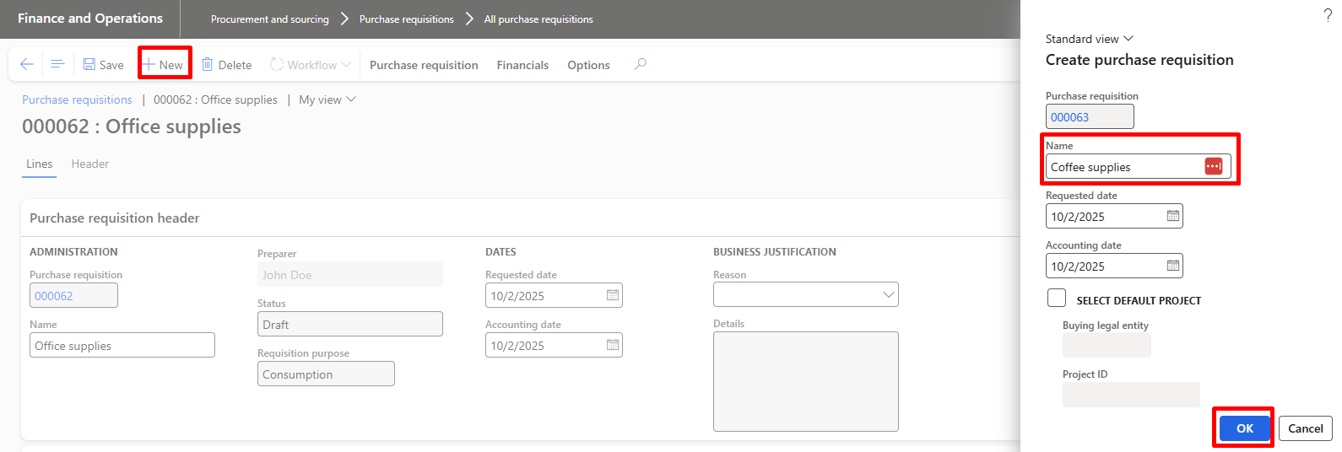
- Select Business Reason from dropdown. 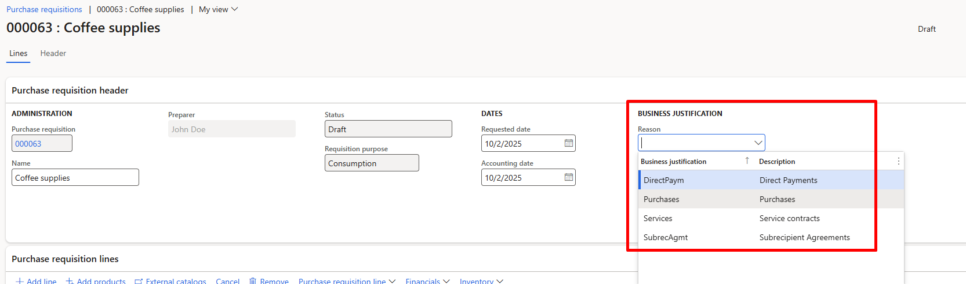
- Scroll down to Purchase requisition lines, click +Add line.
- Enter the following:
- Procurement category
- Product name (it should match the information from the vendor’s quote)
- Quantity
- Unit
- Unit price
- Vendor account (required for workflow).

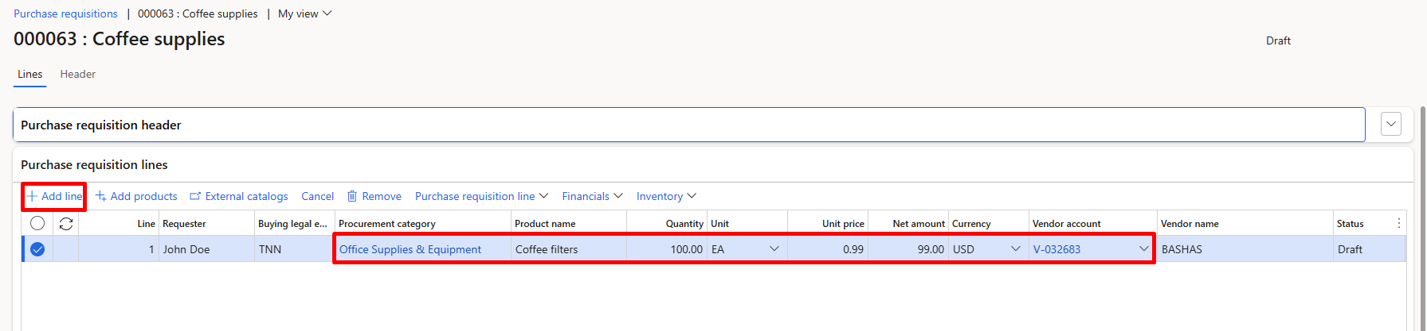
- Click Financials > Accounting > Distribute amounts. 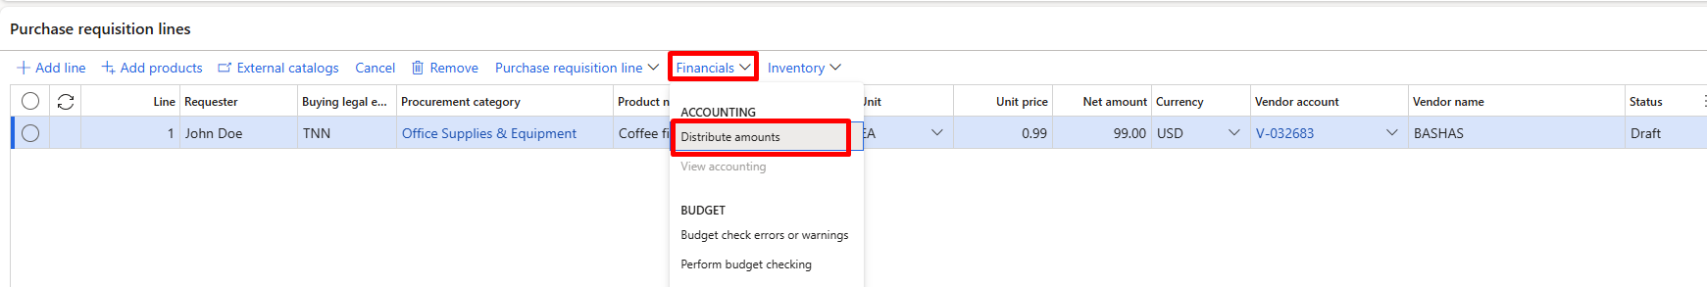
- In the Accounting distributions form, enter the financial dimensions that belong to your department. 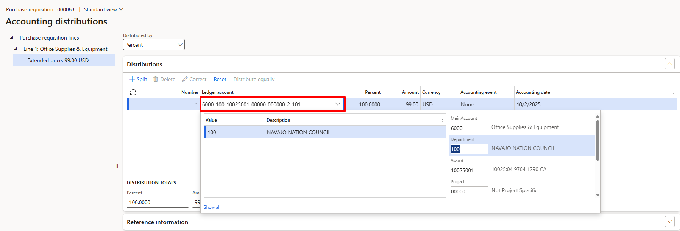
NOTE: A full account string (including all required financial dimensions) must be entered for each purchase requisition line to ensure proper posting and workflow routing.
- Click +Add line to enter additional lines. Repeat steps 7-9.

To enter line details:

- Expand the Line details FastTab (this applies to each individual requisition line). Users may update the following as needed:
  - Item tab (Required)→ In the Item description field, users should paste or enter details from the Product name specific to the Vendor’s quote. (This Item description field is what prints on the Purchase Order line)
  - General tab (Optional)→ Update the Requested date.
  - Address tab (Optional)→ Update the Delivery address.
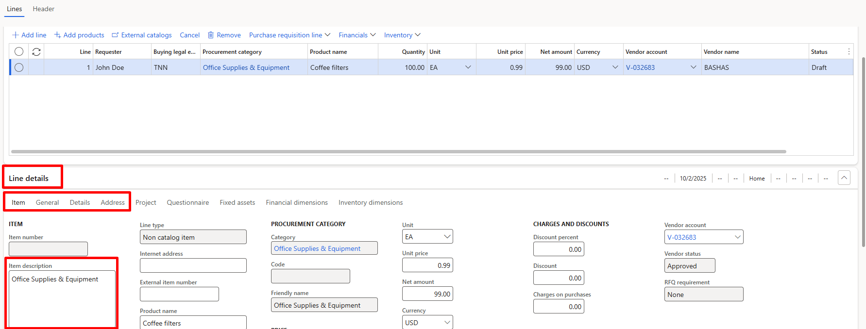

To add an attachment to the Purchase requisition:
Important:
Only attachments added at the Purchase Requisition line level will flow to the Purchase Order. Attachments added at the header level will not carry over.

- Select Line 1 on your Purchase requisition lines > Purchase requisition line > Attachments. 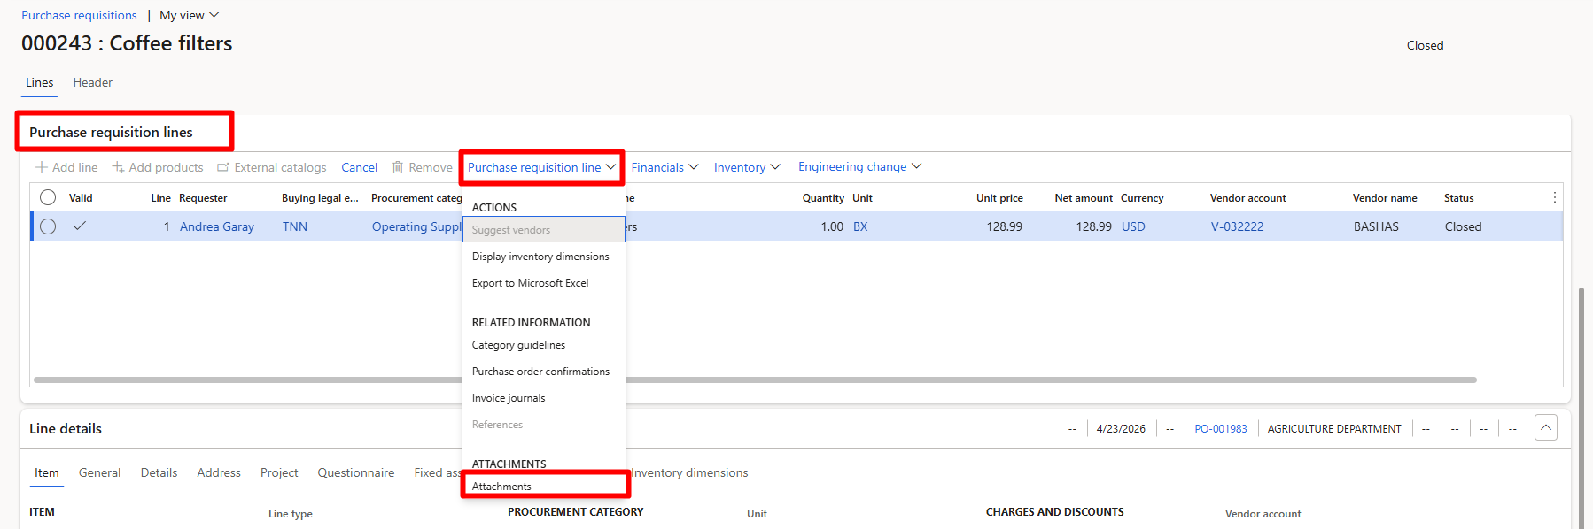
- In the Attachments form:
  - Click + New, select the File type.
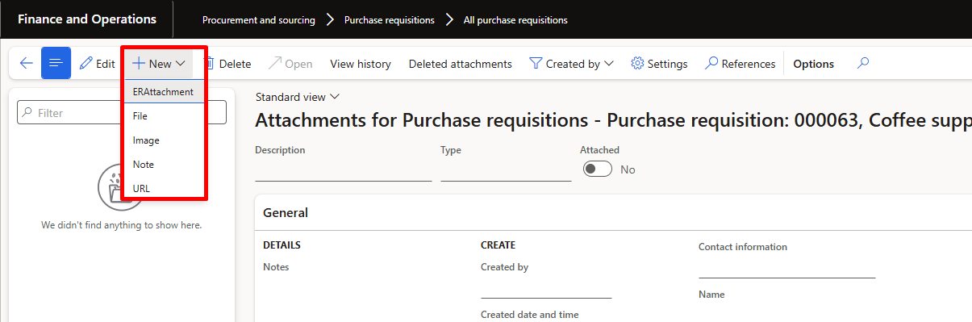

- Browse to upload the attachment.
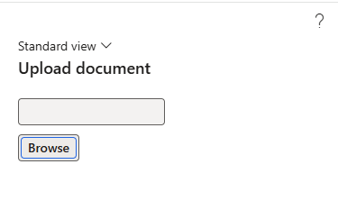
- The file will be uploaded and listed in the attachments grid.
- Close the Attachments form to return to the requisition.
- Once all lines are entered click Save and click Workflow > Submit for approval. 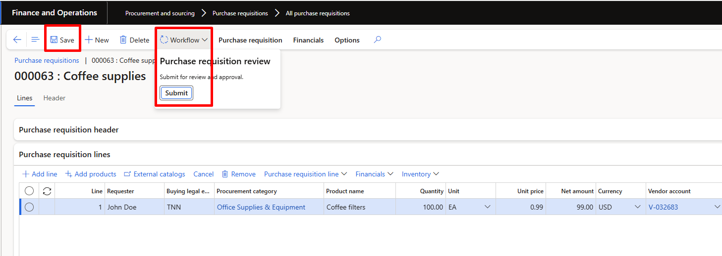

To print a Purchase Requisition Check Off list (formerly 6B form):
- Once the user completes all required requisition information (before submitting to Workflow for approval).
- Click Print Requisition Check Off List.
- Click OK to generate the Requisition Check Off List report. 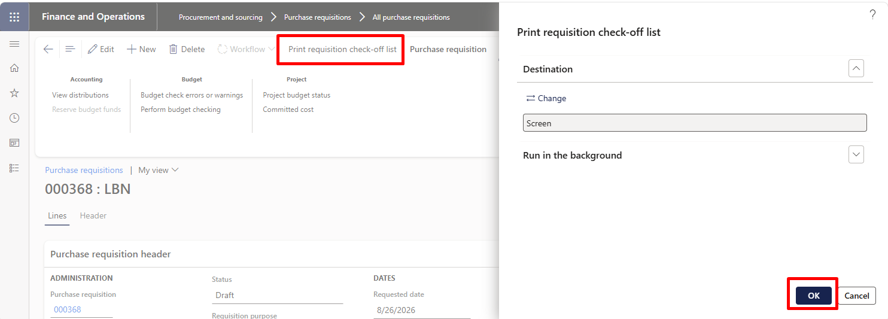
- The Requisition Ckeck Off list prints to the screen, click to Print or Download to obtain required signatures using the printed cover page.
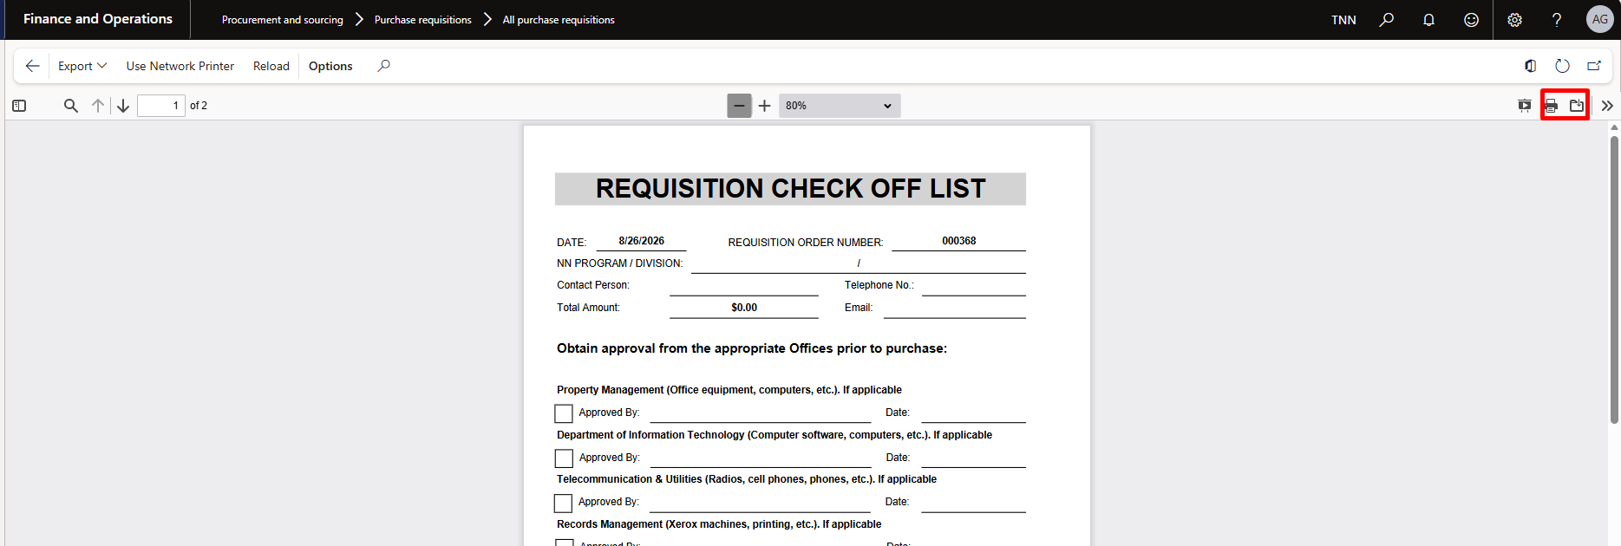
- Once the signatures are gathered, the signed Requisition Check Off List form can be attached to the requisition.
- User submits the requisition for approval.

Entering a Discount on a Purchase Requisition
Sometimes a vendor offers a discount that reduces the cost of a requested item.
Because Purchase Requisitions do not allow negative quantities or negative unit prices, the correct way to reflect a discount is by using the Discount percent field on the requisition line. This reduces the line amount and flows to the Purchase Order after approval.

To enter a discount to a purchase requisition:

- Once the Purchase requisition line to apply the discount is entered, expand the Line details FastTab (this applies per individual line).
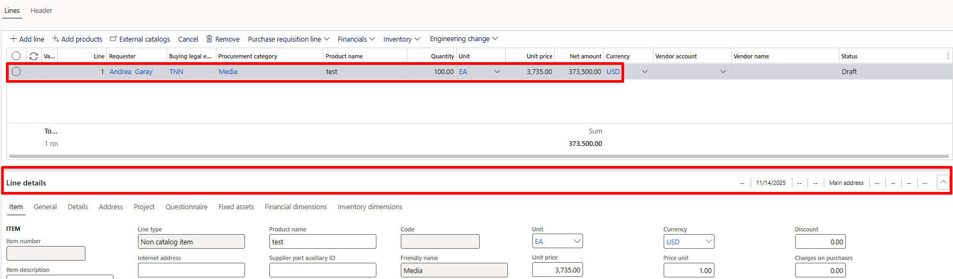

- Click the Price and discount tab.
- In the Discount percent field, enter the discount value (example: 5 for 5%, 10 for 10%).
- Review the Line amount, which recalculates automatically based on the discount.
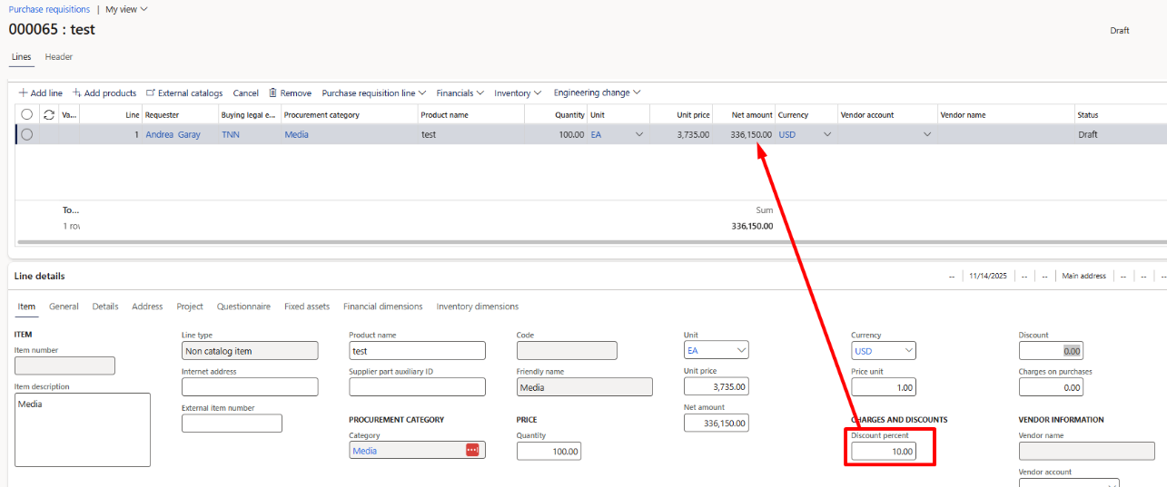
- Click Financials > Accounting > Distribute amounts and verify the financial dimensions for your department.
- Click OK to return to the requisition line.
- Click Save, then Workflow > Submit to route the requisition for approval.

Purchase requisitions statuses
Status | Description
Draft | The requisition has been created but not yet submitted. Users can edit lines, update details, and save changes.
In Review | The requisition has been submitted to workflow. Awaiting approval from one or more approvers.
Rejected | An approver has rejected the requisition. It must be corrected and resubmitted for review.
Approved | The requisition has passed workflow approvals. It is ready to be processed further (e.g., converted to a purchase order).
Closed | The requisition is finalized. Typically occurs once the requisition has been fully converted to a purchase order or manually closed.
Canceled | The requisition has been withdrawn/canceled and will not be processed.

Workflow originator’s capabilities

While a requisition is In Review, the originator can:
- Recall the requisition from workflow to make edits
- Review Workflow history to track progress

To recall the requisition:
- Open the requisition submitted.
- On the Action Pane, click Workflow > Recall.

To open Workflow History
- See steps (Page 7).

Requisition Rejected or Change Requested
The originator will receive a notification (email or in the Action Center) when the requisition status is Rejected or Request change.

To take action:
- Navigate to Procurement and sourcing > Purchase requisitions > All purchase requisitions.
- Open the requisition with status Rejected or Request change.
- On the Action Pane, click Edit.
  - Make the required changes, then Save and resubmit to Workflow.

Requisition Approved
- When a requisition has completed workflow successfully, the status will update to Approved.
- Approved requisition will be converted to a Purchase Order.

Purchase requisitions status flow

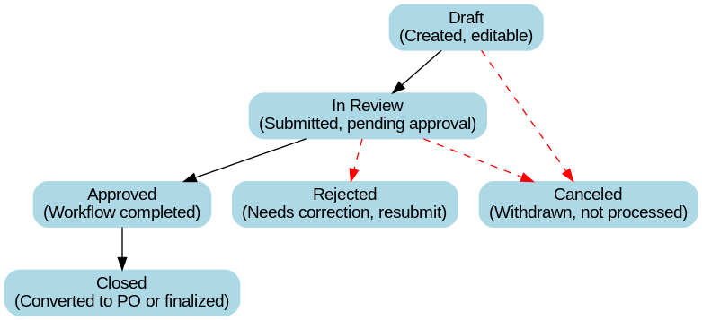

Purchase Requisitions Prepared by Me
This workspace/view allows users to quickly find and manage requisitions they have created. From here, you can track statuses, recall, edit, resubmit, or delete your own requisitions.

To open Purchase requisitions prepared by me:

- Navigate to Procurement and sourcing > Purchase requisitions > Purchase requisitions prepared by me.
- Review the list of requisitions you created, along with their Status (Draft, In Review, Approved, Rejected, etc.).
- Select a requisition and take action as needed:
  - Draft → Continue editing and submit to workflow.
  - In Review → Use Workflow > Recall if changes are needed.
  - Rejected / Request change → Open the requisition, click Edit, make changes, then resubmit.
  - Approved → No further action required; requisition will move forward in the process.

Review Workflow History
- Navigate to: Procurement and sourcing > Purchase requisitions > All purchase requisitions.
- Select and open the Purchase Requisition needed to review.
- On the Action Pane, click Workflow > Workflow history.
- The Workflow history form will open. Here you can view:
  - Workflow status (In progress, Completed, Rejected, etc.).
  - Step-by-step actions taken in the approval process.
  - Approvers’ names and actions (approved, rejected, delegated).
  - Date and time stamps for each action.
  - Comments entered by approvers.
- Expand sections or switch tabs to see more details about each workflow step.
- Close the form when it is finished.

Understanding Budget Control and Purchase Requisitions
The following financial dimensions are used for budget control:
- Department
- Award
- Project

When Is Budget Control Checked?
Budget control is evaluated at multiple points in the procurement process:
- When entering or editing purchase requisition lines
- When updating accounting distributions
- When submitting a requisition to workflow
- When approving a requisition

Important: A requisition may pass budget control at entry but fail later if budget availability changes.

Budget Control Indicators
Budget status is displayed using visual indicators on the purchase requisition line and during workflow actions.

Indicator | Meaning | Action Required
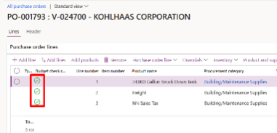 | Budget is available | OK to approve.
⚠️ Warning | Budget exceeded but allowed | Review and justify; approval decision required
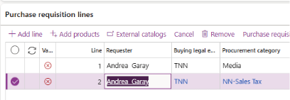 | Budget exceeded and blocked | Funding must be corrected before approval

To view from Budget check errors or warnings:

- Open the Purchase Requisition.
- Navigate to the Financials > Budget check errors and warnings.

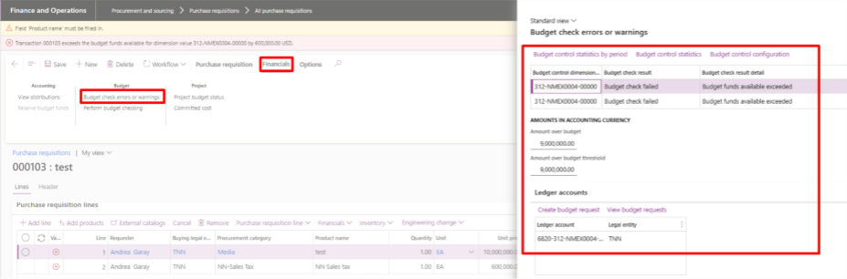
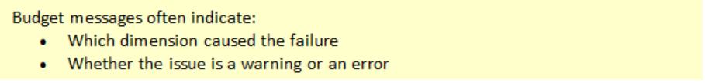

Viewing Budget Control Statistics
Control statistics provide a detailed breakdown of budget availability.
To view Control Statistics:
- Open the Purchase Requisition.
- Navigate to the Financials > Budget check errors and warnings.
- Click Control statistics.
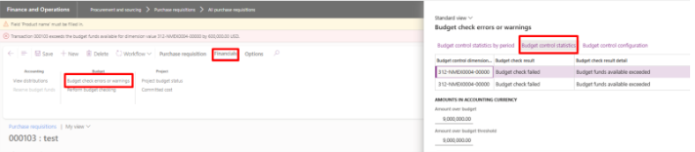
- Make sure budget cycle for the current fiscal year is selected, click Apply parameters. 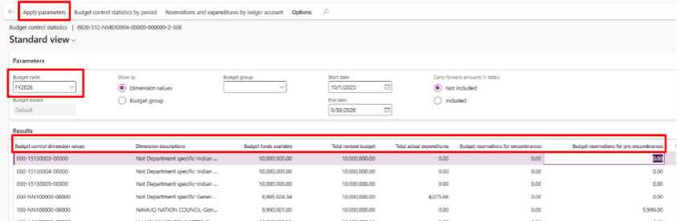

What Control Statistics show:
Columns | Meaning
Budget funds available | Remaining available budget
Total revised budget | Original budget
Total actual expenditures | Actual expenses
Budget reservations for encumbrances | Confirmed Purchase orders
Budget reservations for pre-encumbrances | Approved Purchase requisitions

