This Quick Reference Guide (QRG) helps users understand the Navajo Nation Chart of Accounts, financial dimensions, awards, and how posting works in D365 F&SCM. It also covers key procurement topics such as vendor inquiries, procurement categories, purchasing policies, and the importance of business reasons in the approval workflow process.
Contents
Revision History 1
Navajo Nation Chart of Accounts (COA) Structure 2
Financial Dimensions 2
Awards 3
How Posting Works in D365 F&SCM 3
Procurement & Sourcing 3
Vendor Information (Inquiry Only) 4
Procurement Categories 4
NN purchasing policies (configured in the system): 4
Business Reason 5

Revision History

Date | Author | Comments
10/28/2025 | Andrea Garay | Original draft
04/22/2026 | Andrea Garay | Updated Business Reason  - Changed Service Contract to contracts
05/27/2026 | Andrea Garay | Updated NN purchasing policies  - Added Reapproval rule for purchase orders (PO requires re-approval if changes are made to Procurement Category, Quantity, Unit Price, Net Amount, or Accounting Distributions).

Navajo Nation Chart of Accounts (COA) Structure
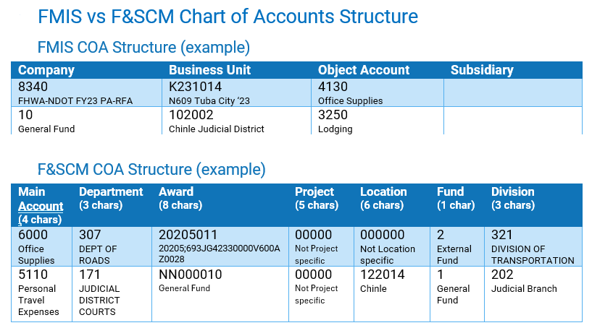

Financial Dimensions
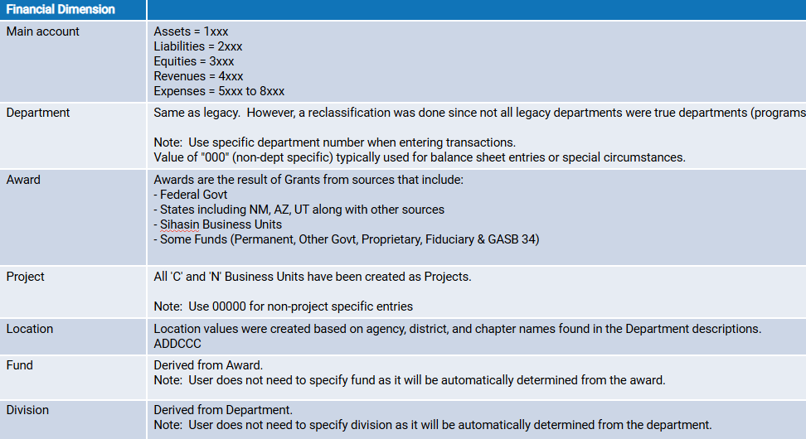

Awards
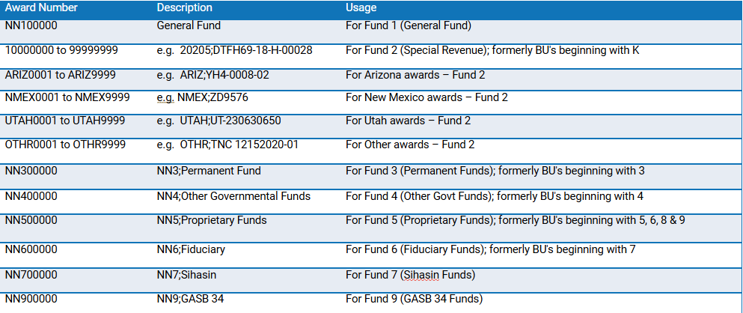

How Posting Works in D365 F&SCM
- D365 requires a full account string for every transaction to post to the ledger.
  - A full account string = Main Account + Financial Dimensions.
- Where the pieces come from:
  - Main Account → comes from the Procurement category.
  - Financial Dimensions → usually manually entered.

Procurement & Sourcing
- Vendor records are created and maintained in Procurement module and in the Accounts Payable Module.
- The Procurement module is used to manage the relationships of vendors and categories and items.
- Requisitions will typically be the starting point for a procurement transaction progressing through to the point of the purchase order and the receipt of goods.

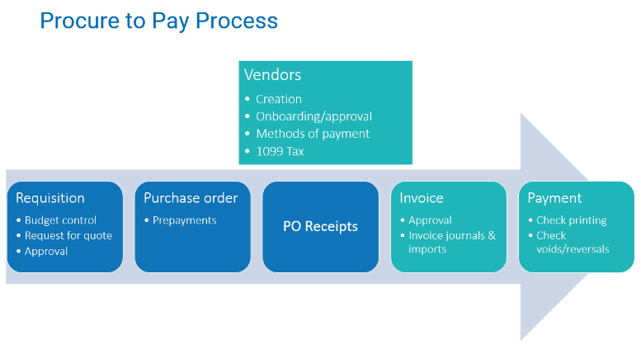

Vendor Information (Inquiry Only)
- Navigate to Procurement and sourcing > Vendors > All vendors
- Vendor record includes:
  - Vendor number & name
  - Contact information
  - Payment terms
  - Method of payment
  - Bank information
- Vendor Inquiries:
  - View Purchase Orders and receipts (outstanding invoices)

Procurement Categories
Procurement categories are used to classify goods and services purchased through requisitions and purchase orders. They provide structure for approvals, reporting, and accounting. Inventory Posting Profiles link procurement categories to main accounts.

To view/edit Procurement categories:
- Navigate to Procurement and sourcing > Procurement categories

NN purchasing policies (configured in the system):
  - Procurement categories are allowed for all vendors.
  - Category matching policy: Three-way matching
  - Reapproval rule for purchase orders (PO requires re-approval if changes are made to Procurement Category, Quantity, Unit Price, Net Amount, or Accounting Distributions).
  - Accrue purchase expenses on receipt.
  - Business reason is required.
  - Requisition purpose rules
  - Approved purchase requisition automatically creates a purchase order.

Business Reason
- The Business Reason provides justification for the purchase and ensures compliance with policy.
- Most importantly, the business reason determines which approval workflow process the requisition follows.
- Without a valid business reason, the requisition cannot be submitted for approval.
