This Quick Reference Guide (QRG) explains how Procurement Categories are configured in Microsoft Dynamics 365 Finance & Supply Chain Management (D365 F&SCM), when a new Procurement Category should be created, and how to map the category to the appropriate Main Account for financial reporting.

This guide is intended for General Accounting staff responsible for maintaining Procurement Categories.

Contents
Procurement Categories Overview 1
Procurement Category Hierarchy 2
Creating a Procurement Category 2
Mapping Procurement Categories to the General Ledger 3

Procurement Categories Overview
Procurement Categories classify the goods and services purchased through Purchase Requisitions and Purchase Orders.
They serve several purposes:
- Classify purchases
- Drive reporting
- Organize the procurement hierarchy
- Determine the Main Account used for accounting

When to Create a New Procurement Category
A new Procurement Category should be created when:
- A new summarized Main Account is added to the Chart of Accounts.
- A new type of good or service requires separate reporting.
- Existing Procurement Categories no longer meet business requirements.
Do not create a new Procurement Category simply because:
- A new vendor is added.
- A different department is purchasing the item.
- A new project or award is created.

Procurement Category Hierarchy
The Procurement Category hierarchy organizes categories into logical groups.
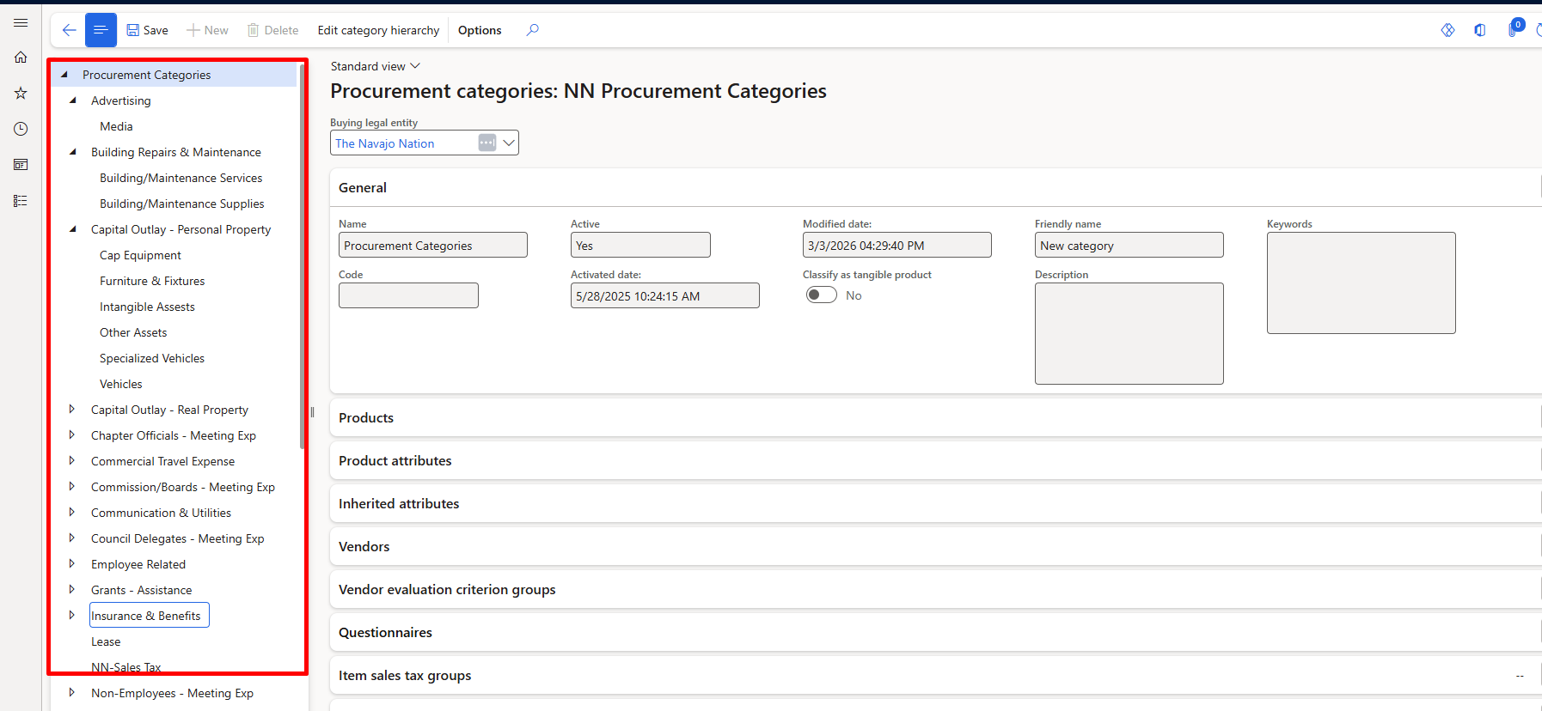When creating a new category, always determine whether it belongs under an existing parent category.

Creating a Procurement Category
- Navigate to Procurement and sourcing > Procurement categories
- Select Edit category hierarchy
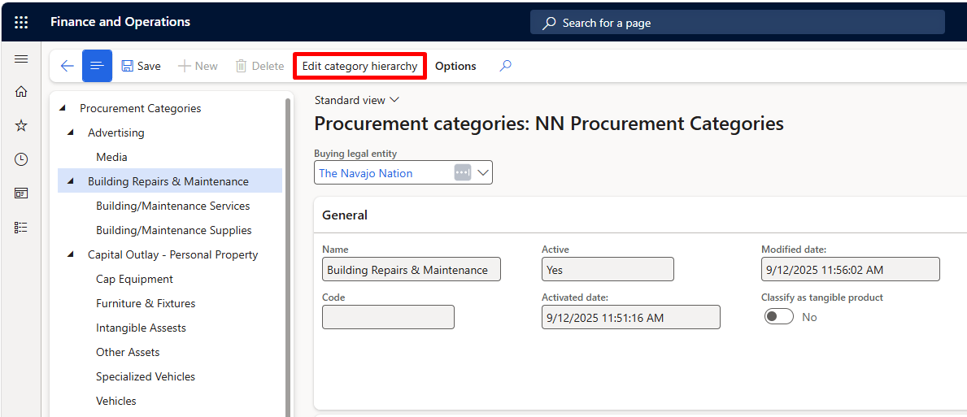
- Select the appropriate Parent Category.
- Select New category node.
- Enter the required information:
- Category Name
- Friendly name (optional)
- Description (optional)
- Save the new Procurement Category. 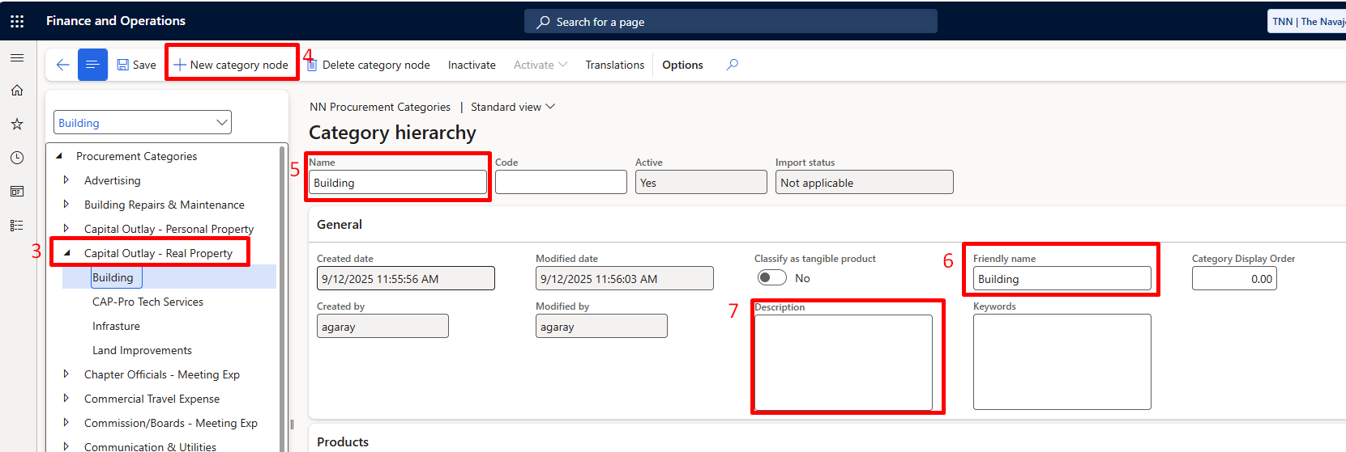

Mapping Procurement Categories to the General Ledger
Each Procurement Category must be mapped to the correct Main Account.
- Navigate to Inventory management > Setup > Posting > Posting.
- Select the Purchase order tab.

Configure the Purchase Expenditure, Uninvoiced Posting Type
- In the Posting type field, select Purchase Expenditure, Uninvoiced.
- Click New.
- In the Item code field, select Category.
- In the Category relation field, select the Procurement Category you created.
- In the Main account field, enter the appropriate accrual account.
- Click Save.

Configure the Purchase Expenditure for Expense Posting Type
- In the Posting type field, select Purchase Expenditure for Expense.
- Click New.
- Repeat Steps 5–8, using the expense Main Account associated with the Procurement Category.
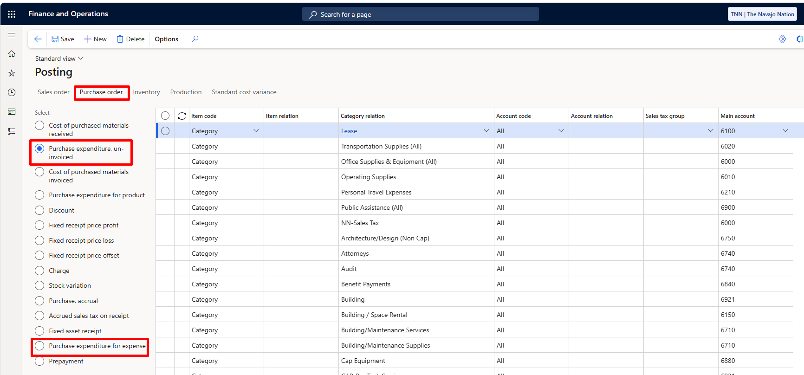

Posting Type Descriptions
Purchase Expenditure, Uninvoiced:
- Records the accrued expense after goods or services are received.
- Represents expenses that have been received but not yet invoiced.
- Is automatically cleared when the vendor invoice is posted.

Purchase Expenditure for Expense
- Records the final expense in the General Ledger.
- Typically maps to the summarized Main Account associated with the Procurement Category.
- Is used when the vendor invoice is posted.
Note: Both posting types must be configured for every new Procurement Category to ensure transactions post correctly throughout the procure-to-pay process

