Contents
Finalize Purchase Order 1

Finalize Purchase Order
The last step of a PO processing after the invoice is generated is to finalize a PO. This action will release any budget and encumbrance reservations against this PO, close the PO and all related activities to prevent users from modifying it.

To finalize a Purchase Order:
- Navigate to Procurement & Sourcing > Purchase Orders > All Purchase Orders
- Select the PO you want to finalize.
Note: only POs that are in status “Confirmed” and “Invoiced” or “Cancelled” can be finalized. Otherwise, the red bar and error message will be displayed
- Click Purchase > Actions > Finalize.
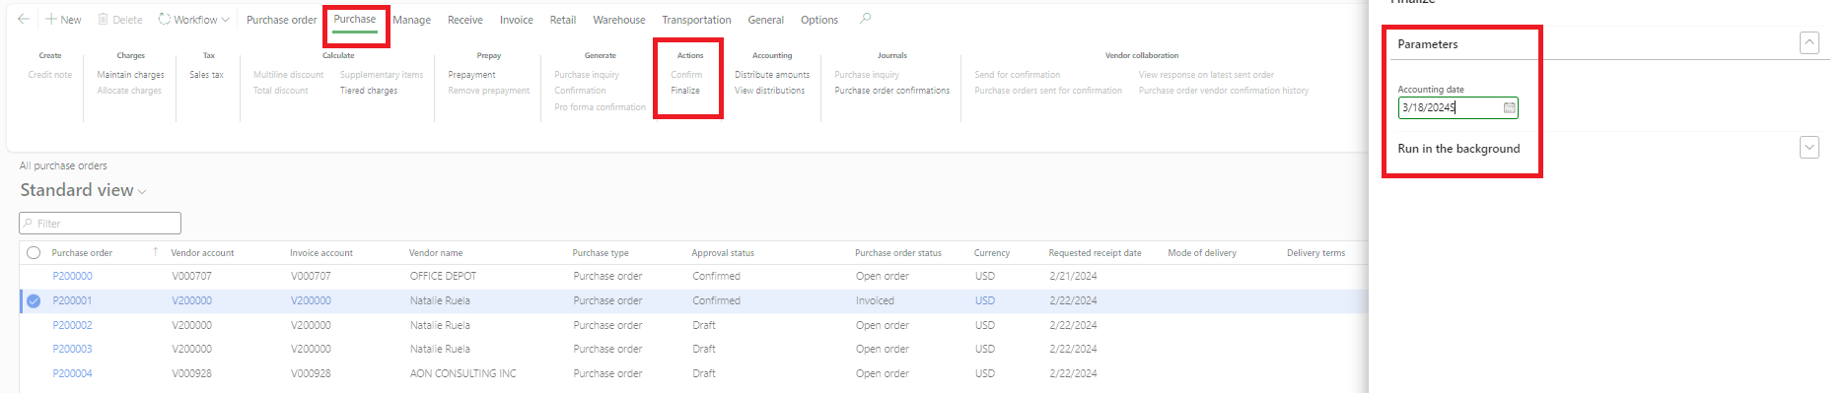
- Select the date of closure (defaulted to current date).

- The Purchase Order will now have a status “Finalized” and the blue bar will indicate that the operation is completed successfully.
