26.18

This Quick Reference Guide (QRG) explains how Budget Control works in Dynamics 365 Finance & Supply Chain Management (F&SCM) from a Procurement user perspective. It helps users understand budget indicators, review budget availability, interpret system messages, and take appropriate action when entering or approving Purchase Requisitions.
Budget control ensures that sufficient funds are available before commitments are created and routed for approval.

Contents
Budget Control Parameters 1
When Budget Control Is Checked? 2
How to View Budget Control Messages 2
Viewing Budget Control Statistics 3
Budget Control and Workflow 4
How Budget Control Reserves Funds (Procurement Lifecycle) 5
Budget Reservation Stages 5

Budget Control Parameters
The following financial dimensions are used for budget control:
- Department
- Award
- Project
These dimensions collectively define the budget checking granularity. Budget is validated for each unique combination of these dimensions.
The other dimensions (Division, Fund, and Location) are available for budgeting but are not used for budget control enforcement.
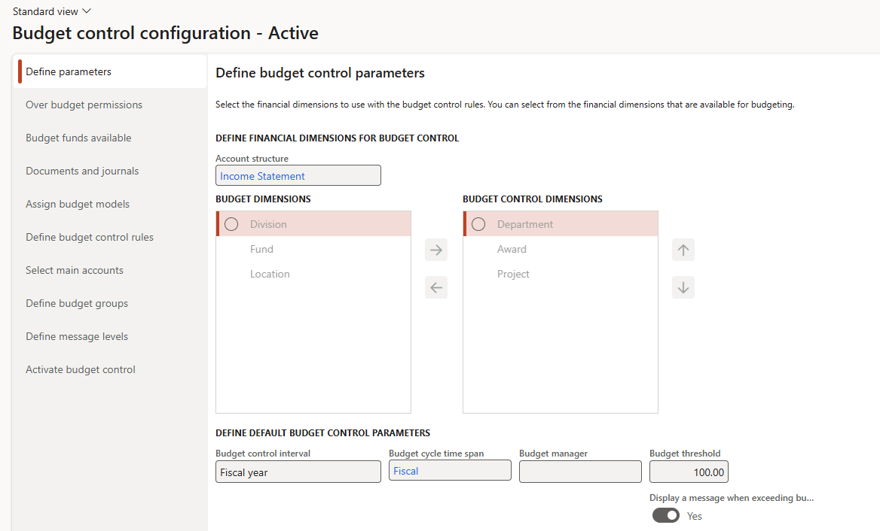

When Budget Control Is Checked?
Budget control is evaluated at multiple points in the procurement process:
- When entering or editing purchase requisition lines
- When updating accounting distributions
- When submitting a requisition to workflow
- When approving a requisition

Important: A requisition may pass budget control at entry but fail later if budget availability changes.

Budget Control Indicators

Budget status is displayed using visual indicators on the purchase requisition line and during workflow actions.

Indicator | Meaning | Action Required
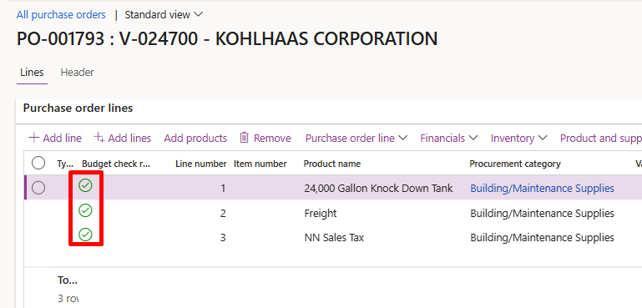 | Budget is available | Continue processing
⚠️ Warning | Budget exceeded but allowed | Review and justify; approval decision required
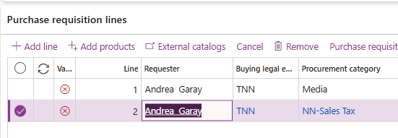 | Budget exceeded and blocked | Funding must be corrected before submission

How to View Budget Control Messages
To view more information on budget icon:

- Open the Purchase Requisition.
- Navigate to the Purchase requisition lines section.
- Review the budget control icon displayed on each line to view the budget message explaining the issue.
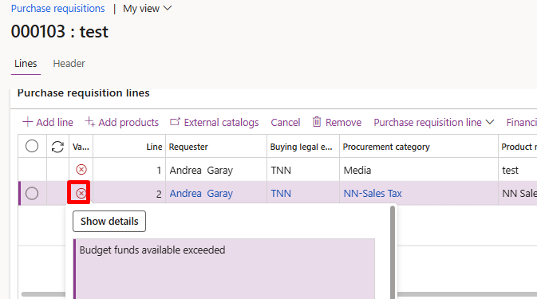

To view from Budget check errors or warnings:

- Open the Purchase Requisition.
- Navigate to the Financials > Budget check errors and warnings.

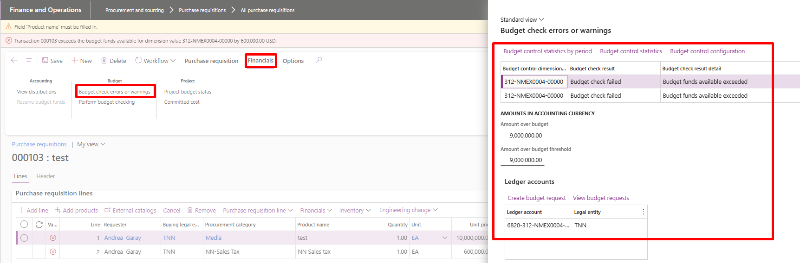
Budget messages often indicate:
- Which dimension caused the failure
- Whether the issue is a warning or an error

Viewing Budget Control Statistics
Control statistics provide a detailed breakdown of budget availability.
To view Control Statistics:
- Open the Purchase Requisition.
- Navigate to the Financials > Budget check errors and warnings.
- Click Control statistics. 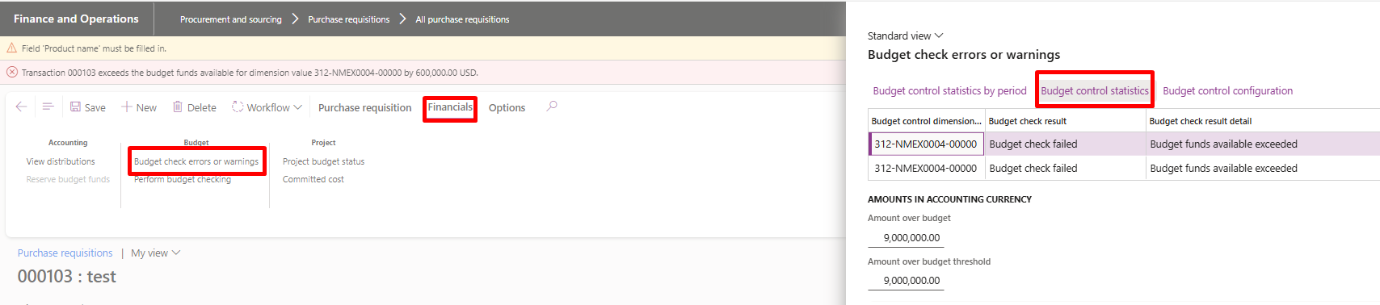
- Make sure budget cycle for the current fiscal year is selected, click Apply parameters. 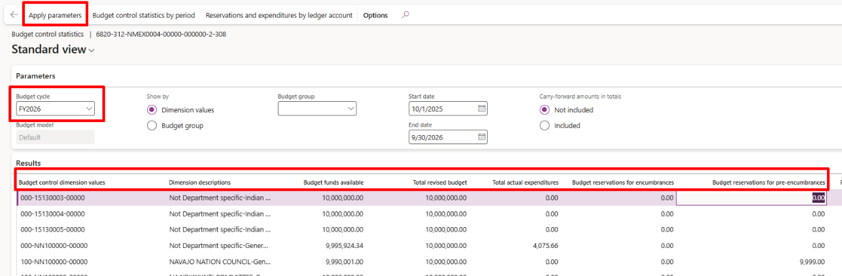

What Control Statistics show:
Columns | Meaning
Budget funds available | Remaining available budget
Total revised budget | Original budget
Total actual expenditures | Actual expenses
Budget reservations for encumbrances | Confirmed Purchase orders
Budget reservations for pre-encumbrances | Approved Purchase requisitions
Control statistics are read-only and are used for analysis and validation.

Budget Control and Workflow

- Budget errors must be corrected before submission.
- Submitting with a budget error will fail workflow and delay processing.
- Budget warnings (⚠️) may be submitted, subject to approval policy.
- If you are unsure how to resolve a budget error, review Control statistics or contact the Budget/Finance team.
- Approvers see the same budget indicators and messages.
❌ Do NOT submit to workflow if a budget error exists. 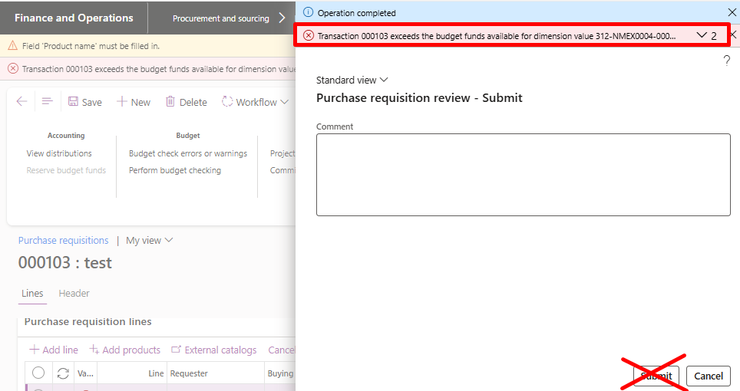

How Budget Control Reserves Funds (Procurement Lifecycle)
Budget control does not post accounting entries. Instead, it reserves budget as transactions move through the procurement process to prevent overspending.

Budget Reservation Stages
1. Purchase Requisition Approved – Pre-Encumbrance
- When a Purchase Requisition is approved, budget control creates a pre-encumbrance.
- A pre-encumbrance:
  - Reserves funds for the requested purchase
  - Reduces available budget
  - Does not create a legal obligation
✔ This ensures funds are reserved while approvals are in progress.

2. Purchase Order Confirmed – Encumbrance
- When a Purchase Order is created and confirmed, the system:
  - Releases the pre-encumbrance
  - Creates an encumbrance
- Budget control now reflects the encumbrance instead of the requisition.
✔ Funds remain reserved, now tied to a confirmed PO.

3. Vendor Invoice Posted – Actual Expense
- When a vendor invoice is posted:
  - The encumbrance is reduced or cleared
  - The amount becomes an actual expense
- Budget control updates:
  - Actuals increase
  - Available budget decreases accordingly
✔ Budget moves from commitment to actual spending.

4. Purchase Order Finalized – Final Budget Cleanup
- When the PO is fully invoiced and/or cancelled/finalized:
  - Any remaining encumbrance is released
  - Budget control reflects final actual amounts only

