This Quick Reference Guide (QRG) explains how to apply a discount to a Purchase Order line before goods are received or directly on the vendor invoice line in D365 F&SCM.
Applying the discount early ensures the correct cost and accounting impact are reflected during receipt and invoice matching.
Contents
Apply a Discount Before PO Receipt or at the Invoice Line 1
Apply Discount at the Vendor Invoice Line 2

Apply a Discount Before PO Receipt or at the Invoice Line

- Navigate to Procurement and sourcing > Purchase orders > All purchase orders.
- Locate and open the Purchase Order to update.
- In the Purchase order lines FastTab, select the line you want to apply a discount to.
- Expand the Price and discount FastTab (at the bottom of the screen). 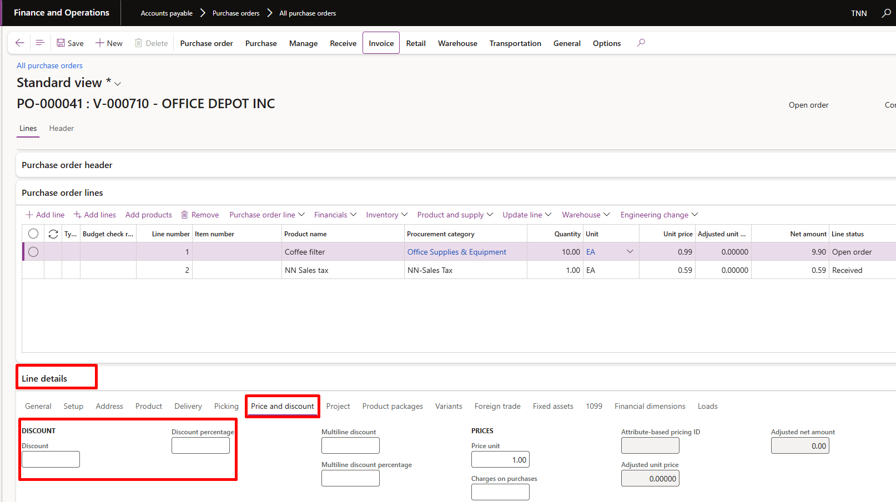
- In the Discount percent or Discount amount field:
  - Enter a percentage (e.g., 5%), or
  - Enter a flat discount amount (e.g., $100.00).

- Verify that the Net amount recalculates to reflect the discount.
- Click Save.
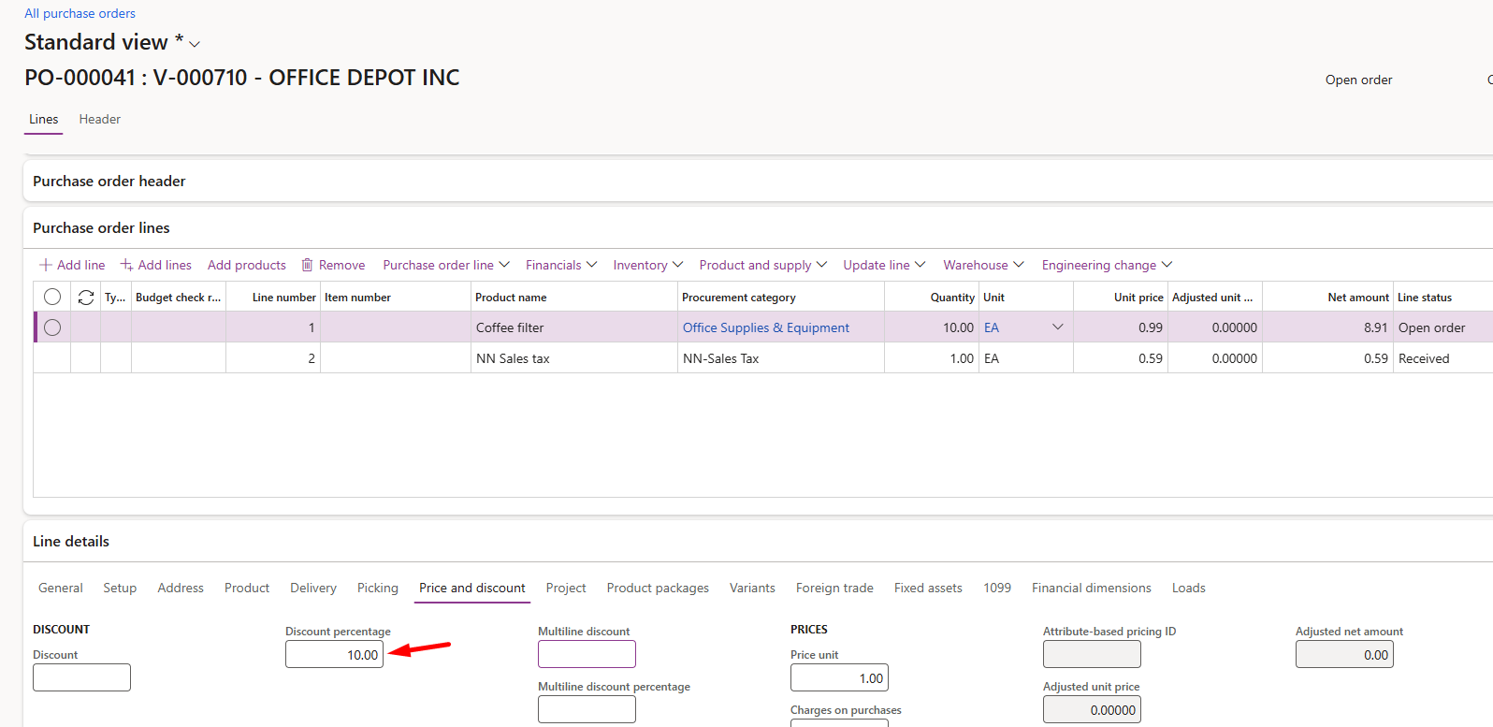
- Review the Line amount to confirm that the discount is applied correctly.
- Confirm the PO.
Discounts applied at the PO level flow automatically into the product receipt and vendor invoice, ensuring consistent amounts across processes The Line

Apply Discount at the Vendor Invoice Line
- Navigate to Procurement and Sourcing > Purchase orders > All purchase orders.
- Locate and open the Purchase Order to invoice.
- Go to Invoice > Generate > Invoice.
- Enter the Vendor invoice number and other required fields.
- Under Invoice lines, select the line where the discount applies.
- Scroll to the Price and discount FastTab.
- In the Discount percent or Discount amount field:
  - Enter the applicable discount value.
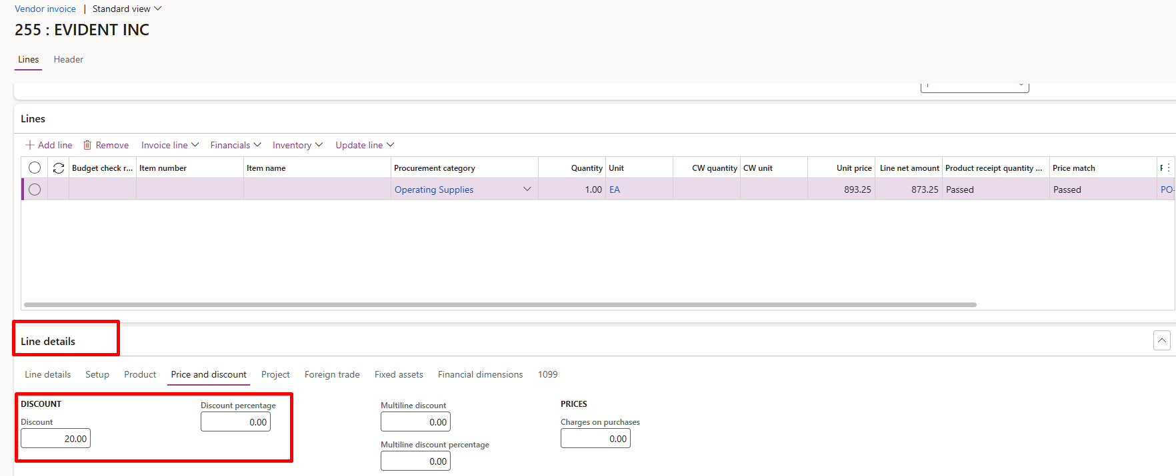

- Verify the recalculated Line amount.
- Once verified, submit to Workflow and Post once approved.

