This Quick Reference Guide (QRG) explains how to reverse a posted product receipt in D365 F&SCM. Reversing a product receipt cancels the previously received quantity, updates inventory and financial commitments, and reopens the purchase order line for correction or re-receipt.

Contents
To reverse a Product Receipt 1

Before You Begin
- The Purchase Order (PO) must be in Received or Partially received status.
- The product receipt cannot be reversed if it has already been invoiced.
- The user must have security access to perform receiving and reversal actions.
- Always communicate with Procurement or Accounts Payable before reversing a receipt tied to encumbrances or posted transactions.

To reverse a Product Receipt
- Navigate to Procurement and Sourcing > Purchase orders > All purchase orders.
- Locate and open the purchase order for which the receipt needs to be reversed.
- On the Action Pane, click the Receive tab.
- Select Product receipt > Product receipt journal. 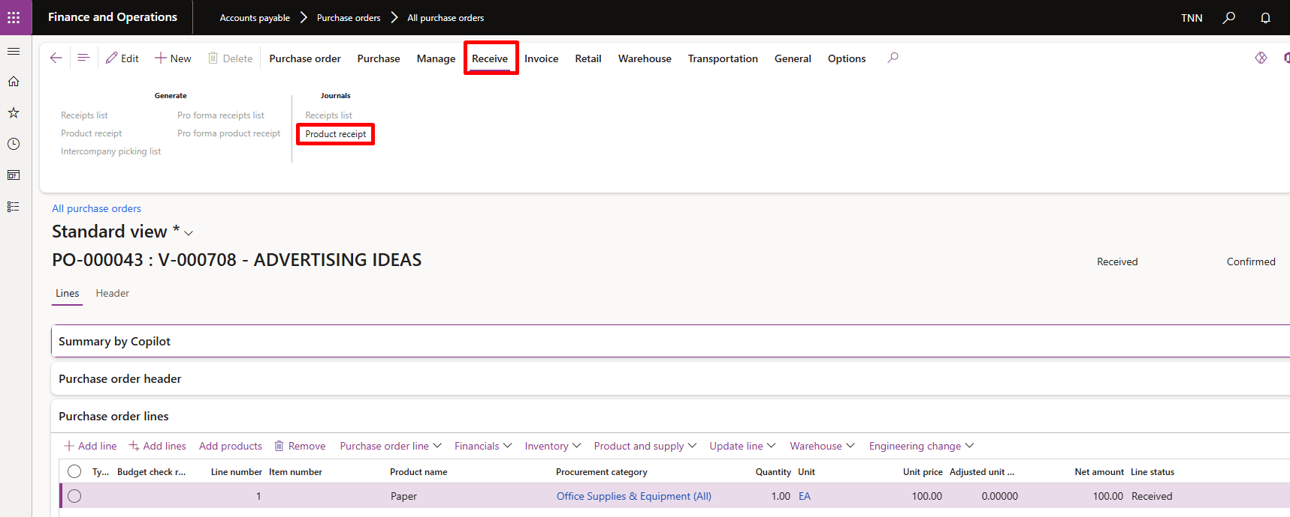

- In the list, identify the product receipt number you want to reverse.
- Highlight the record, then click Cancel > Cancel product receipt on the Action Pane.
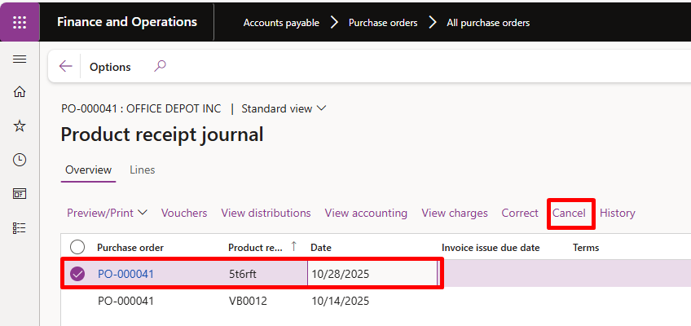
- Click Yes to proceed.
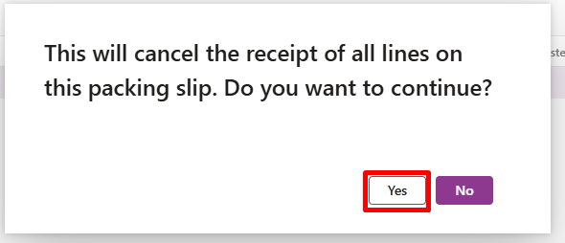
- The Received quantity updates, and the PO line returns to an Open order status.

After Reversal
- If required, create a new product receipt once the correct goods or quantities are available.
- Verify the PO status and quantities under Line quantity > General > Related information to confirm the reversal.
- Notify the appropriate approvers or AP if the change impacts encumbrance balances or pending invoices

