This guide provides step-by-step instructions for navigating and personalizing Microsoft Dynamics 365 Finance & Supply Chain Management (D365 F&SCM). It is designed as a quick reference for new users to get started with common features such as logging in, navigating modules, adding favorites, filtering data, and saving personalized views.

Contents
Logging in D365 FSCM 1
Navigation 2
Favorites 3
Filter Pane 4
Grid column filtering & sorting 5
Insert Columns 5
Hide columns 6
Standard Views 6
Saved Views 6

Logging in to D365 FSCM
SAT (Test/Training) Environment
- Open Google Chrome or Microsoft Edge.
- In the address bar, enter the SAT environment link:
- https://nn-sat2.sandbox.operations.gov.microsoftdynamics.us/?cmp=TNN&mi=DefaultDashboard
- When the login page appears, enter your Office 365 credentials.
- If prompted, complete multi-factor authentication (MFA).
- Once logged in, you will see the D365 home page.
First Login Tips
- Bookmark the SAT link for quick access later.
- If you receive an error, clear your browser cache and retry.
- Always use Chrome or Edge (do not use Internet Explorer).

Navigation
Home Screen

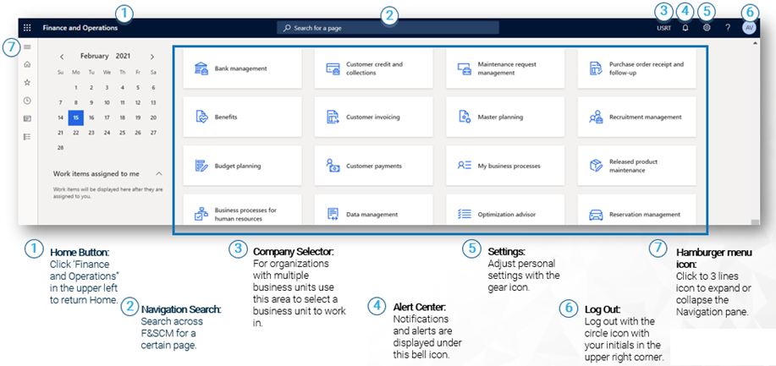

Navigation pane
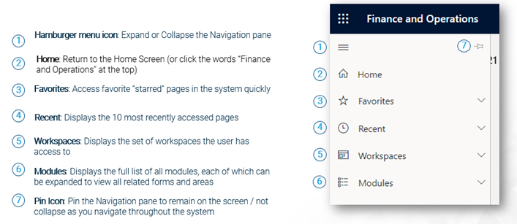

Action Pane

- The Action pane appears at the top below the navigation bar of every page in D365 F&SCM.
- It shows the actions available for the page you are on (e.g., New, Edit, Post, Export to Excel).
- Options change depending on the form or list page you are viewing. 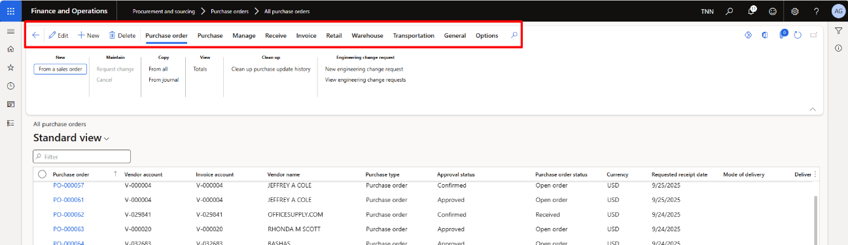

Favorites
Favorites are a way to create shortcuts to forms, reports, and inquiries.

To add a favorite, follow the steps below.

- Open the navigation menu.
- Click the star icon next to the menu item you want to add. 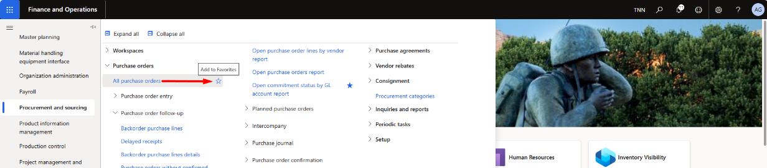
  - The star will highlight, and the item will now appear in your Favorites list. 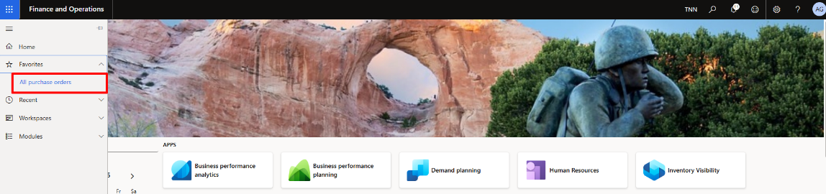

- To remove the favorite, click the star icon again.

Filter Pane
The Filter pane lets you narrow down list pages in D365. It slides in from the right when you click Show filters and stay open until you close it or leave the page. You can add multiple fields and criteria to refine your results.
Using the Filter Pane in D365 F&SCM
- Navigate to the list page you want to filter (e.g., Customers, Vendors, Invoices).
- Click Show filters on the right side of the page.
- Click +Add to select filter fields.
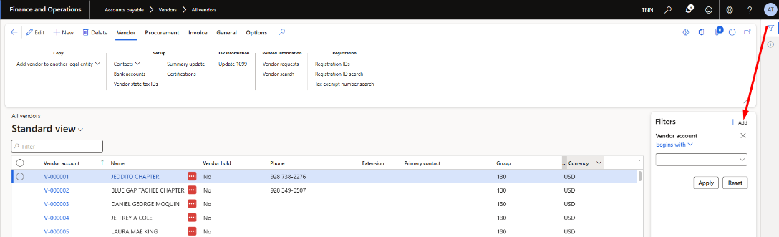
- Choose the fields and click Update. 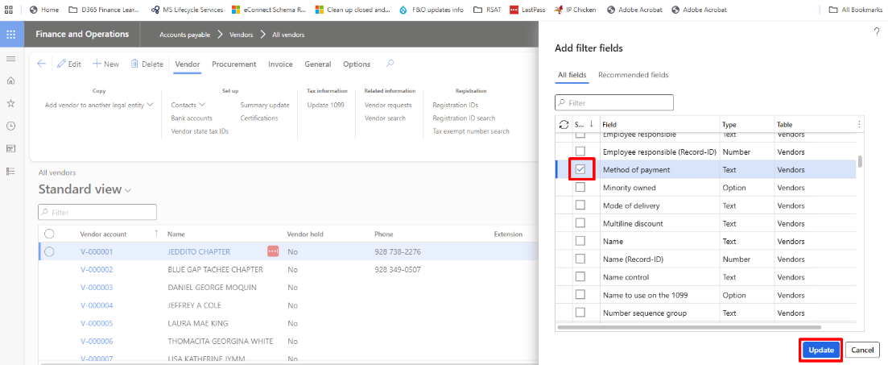
- Enter your filter criteria and click Apply. 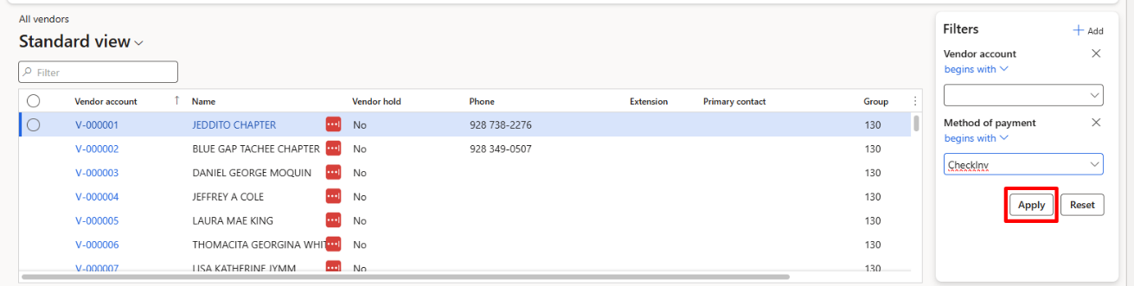
- Review the filtered results.

Grid column filtering & sorting
You can filter or sort directly from column headers, like Excel. Click the drop-down on a column to set filter criteria or sort order.
Using the Grid column filtering & sorting
- Navigate to any list page (e.g., Customers, Vendors, Invoices).
- Click the drop-down arrow on the column header you want to filter or sort.
- Enter filter criteria or choose a sort option, then click Apply. 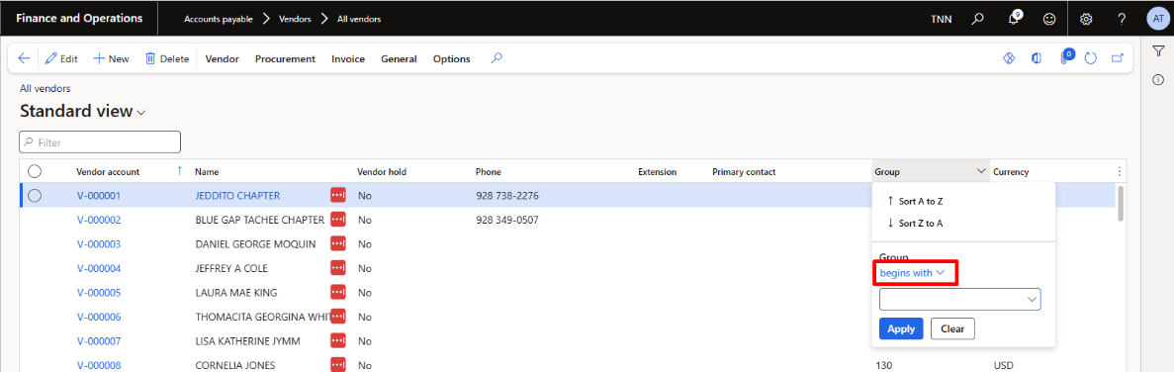
- Clear the filter values to remove the filter.

Insert Columns

Steps to insert columns
- On a list page, click the ellipses (…) button in the grid.
- Select Insert columns. 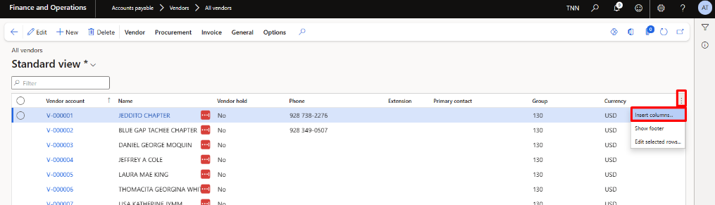
- Choose the column(s) you want to add and click Update. 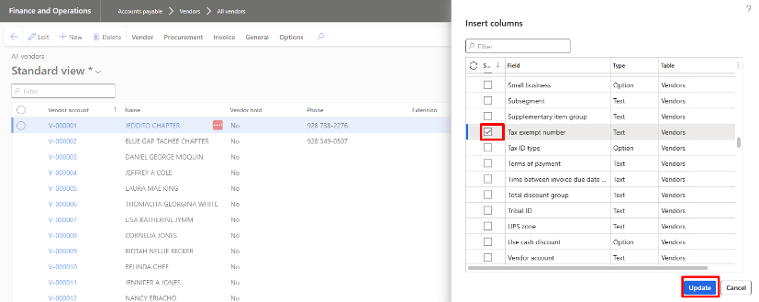
- The new columns appear on the list page.

Hide columns
Steps to hide columns
- Right click on the column heading
- Click hide column
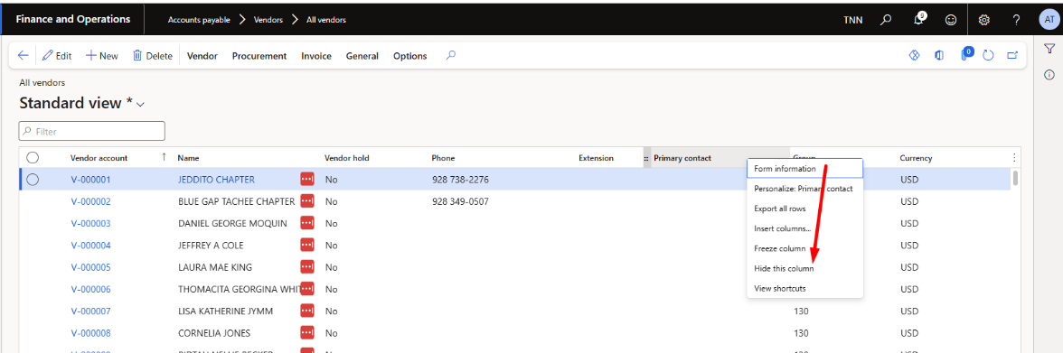

Standard Views
- Every form has a Standard view that cannot be removed.
- If you change the view (e.g., add a filter or column) but don’t save it, an asterisk (*) appears next to “Standard view.” 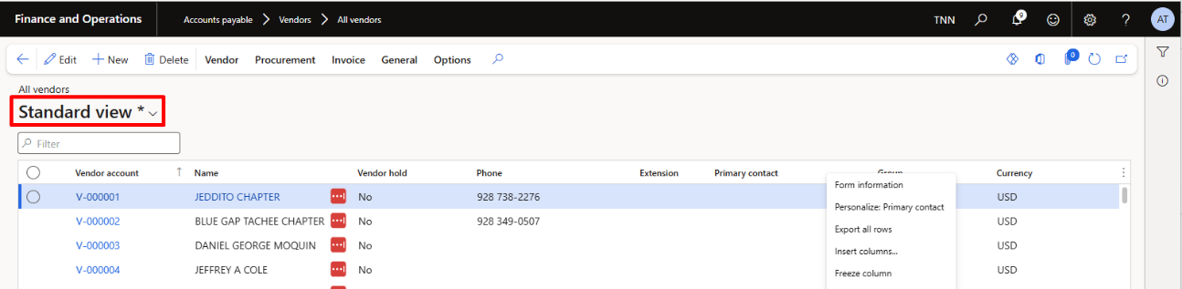

Saved Views
- Saved views let you store your personalizations (filters, columns, sorting) under a named view.
- You can create multiple views and switch between them as needed.

Steps to Create a Saved View
- Apply a filter or personalization to a form.
- Click the down arrow next to Standard view.
- Select Save as. 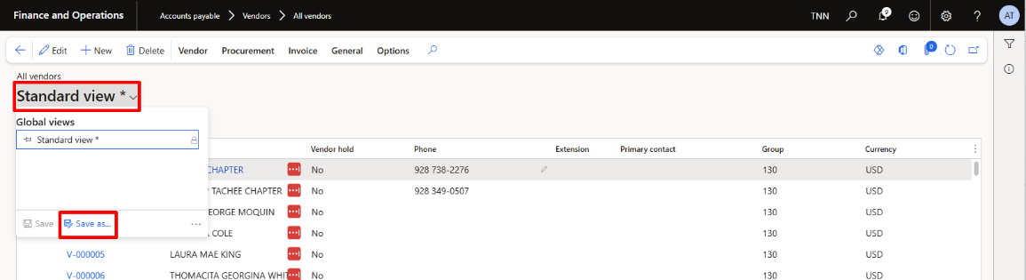
- Enter a Name (and optional Description).
- Toggle Pin as default view to Yes if you want it as your default.
- Click Save. 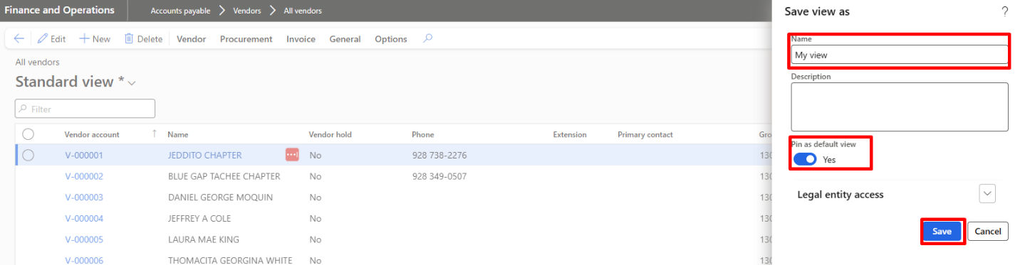

Steps to Delete a Saved View
- Click the down arrow to open the views menu.
- Select the ellipses (…) → Manage my views. 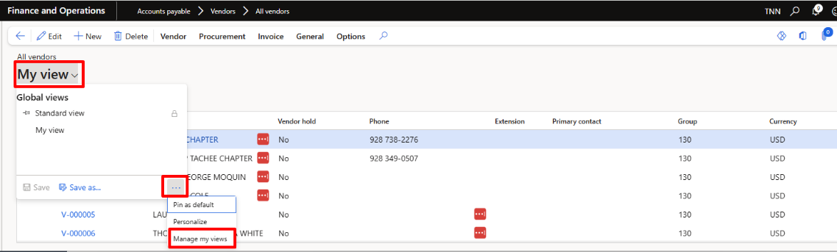
- Select the view you want to delete.
- Click Delete.
- Click Update to confirm.

